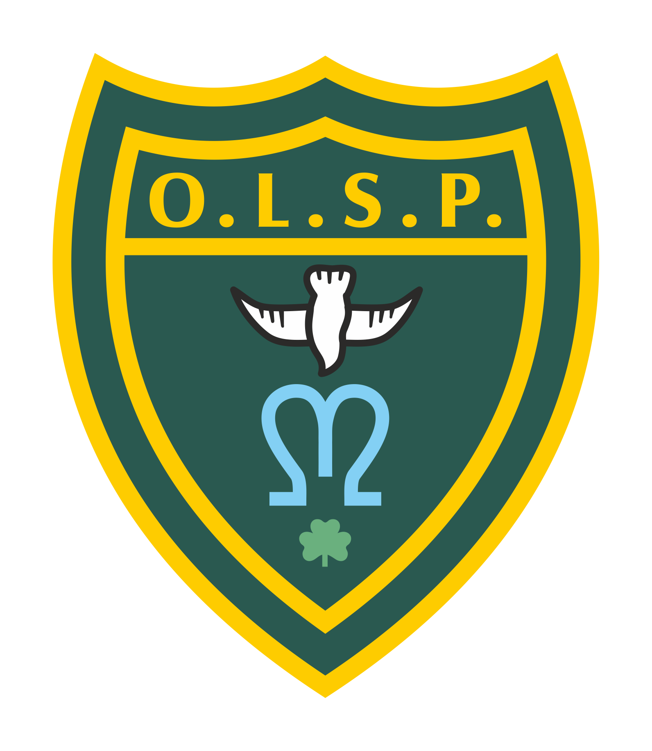
Our Lady and St Patrick’s RC Primary School

Autumn 1 Curriculum Newsletter

Class 4 - Saturn Class Autumn 1 2023

 | Teacher’s Message | 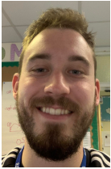  Hello to all of the lovely parents and carers to the children in Class 4! I hope you all have had a fabulous break.  Please read on to find out about all the new and exciting learning we will be immersing ourselves over this half term.  Here is a photo of myself so you know what I look like in case you do not know who I am. Please come and say hello if you see me!
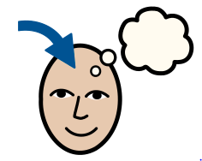 | Homework | Homework is posted on a Monday and the spelling test will be on a Friday.  English:  Weekly spellings are set each Monday. Each week, the children receive a list of 10 words which will focus on practising new spelling rules. The spellings will be uploaded on Class Dojo and a copy will be sent home for the children to practise.  - Weekly spelling tests take place on Fridays.  - Please make sure regular practice takes place.  Maths:  Later on in the term, pupils will be learning their times-tables whereby they will have a particular set of tables to focus on each week.  I will post more information about this in due course later on in the term.
 | Reading for Pleasure | 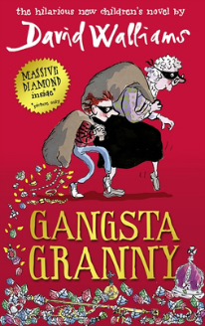  For this half term, the children will be reading Gangsta Granny by David Walliams.
 | English | 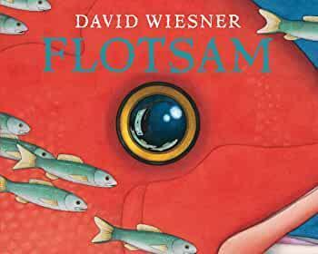  For writing, the children will be focussing on the story ‘Flotsam’ by David Wiesner. The children will carefully look at how the story is structured and re-create their own version of the story.  After we have finished Flotsam. The children will then be looking at the ‘Myth Atlas’ focussing on different Greek Gods.  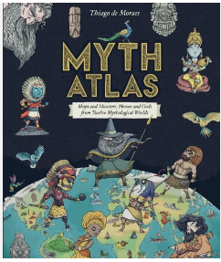  The children will have regular handwriting practice in class each week to ensure they are attempting to join their letters correctly and fluently in year 4.
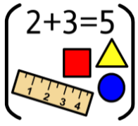 | Maths | In the first term for maths, the children will be looking closely at place value. We will be securing our understanding of knowing the value of a four-digit number as well as rounding to the nearest 10 and 100. We will also be looking to apply our knowledge to using our addition and subtractions using the column method.
 | RE | Throughout RE, the children will be using the Come and See programme and thinking specifically about People. We will be looking at our own families and how God fits into our family too.
 | Science | For science, the children will be learning about a range of things in our animals including humans’ topic of learning. The children will be learning about the digestive system, the animal food chain, the different types of teeth and teeth hygiene. This is one of my favourite topics to teach. I am really looking forward to teaching this to your children!
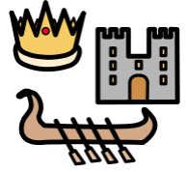 | History | For history this term, Class 4 will be placing their attention to learning about Ancient Greece. As a class, we will be exploring the early parts of Greece with what different excavations can tell us about Ancient Greece itself. We will also be comparing the life between the two city-states Athens and Sparta as well as looking at Alexander the Great.
 | Geography | Not a lead subject this term.
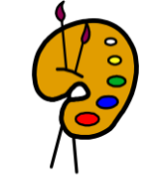 | Art | In art for this term, pupils will be making their own Indigenous clay pots. The children will be planning and making their own clay pots adding different Indigenous details and colours.
 | Design Technology | Not a lead subject for this term.
 | RSHE | Within RSHE and PSHE, the children will be following the ‘Life to the Full’ programme. The unit of learning will be teaching the children about the Gospel story of Jesus with how we should be looking after one another with how we can do that inside and outside of school.
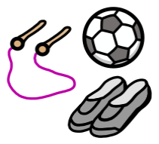 | PE | In PE, the children will be learning different skills about how to pass, score and defend in netball. The children will also be learning the required skills in tag rugby, participating in different drills and games as a class. Tag rugby will be taught by Mr Selley of Premier Sports who taught the children last academic year which will be taught on a Friday morning.  PE will be taken on a Wednesday and Friday each week.  Please ensure your child brings in their PE kit on these days and it is clearly labelled with their first name and surname.
 | Music | For music, the children will be taught by Mr Hopkins on a Friday morning. The children will be learning how to play different musical instruments together collectively.
 | MFL (Y3+) | In Spanish, Mrs Emmerton will be taking Class 4 for an hour every Friday where she will be teaching the children Spanish vocabulary about different musical instruments.
 | Computing | For computing, the children will be learning about online safety and different ways with how we can keep safe online when using the internet.
 | Teacher contact: | Please come and see me if you have any worries or concerns. If this isn’t possible then please contact me through Class Dojo.  Please note that teachers are teaching from 8.30am - 3.15pm. If your contact is urgent please contact the school office office@olsp.uk during the school day.  There is no requirement for a teacher to reply to email or class dojo messages received after 6pm or at the weekend.

