Healthy snack policy

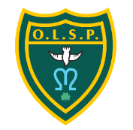

**Created by The OLSP Pupil leadership team**

**Created February 2023**

**Reviewed: Jan 24 and Jan 25**

**To be reviewed annually by the OLSP pupil leadership**

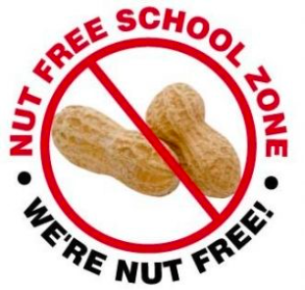

**Introduction**

It is the responsibility of pupils, staff, governors and parents to create a positive environment within the school where pupils learn and adopt the benefits of healthy eating which supports a healthy lifestyle. This policy aims to give information and advice on how to ensure a positive approach to eating for health is introduced, encouraged and embedded.

**Useful information about children’s guideline daily allowances:**

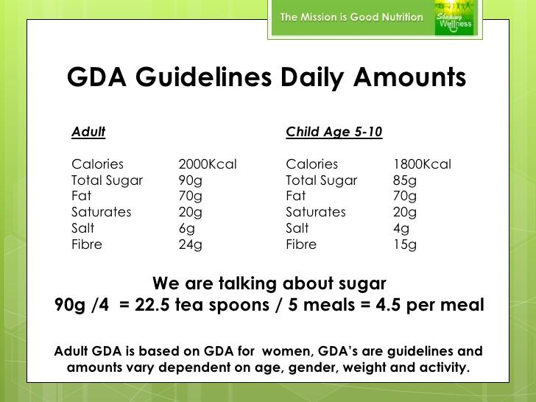

**Aims and expectations**

To make sure that positive attitudes to healthy eating and living are promoted and developed throughout the school and in the wider community.

**Implementation**

The school will ensure that the curriculum promotes healthy eating. Parents, staff and governors will raise pupil awareness of keeping healthy through eating and drinking a varied diet, eating appropriate sized portions, taking exercise, having enough sleep, keeping clean and brushing teeth.

Pupils and parents will be encouraged to contribute to healthy eating by adhering to the healthy snack list suggested by the school.

**School snacks**

For EYFS and Key Stage One we will provide health promoting foods and healthy beverages during morning snack time.

Examples include:

• Water

• Semi skimmed milk (for EY only)

• Vegetables

• Dried fruits (small amount as these contain concentrated sugar)

• Fruit

Limit high-fat, high-calorie foods and beverages. If such items are used [e.g. parent brings in a birthday treat], this should be cut in quarters to encourage small portions.

Examples include: doughnuts, pastries, high-fat muffins, scones, birthday cakes, cookies etc. If sweets are brought in to be shared as a part of a celebration they must remain unopened and sent home in book bags and should only be eaten with permission from a parent or responsible adult. We do, however, encourage the use of health-promoting foods that can be shared in school to celebrate special occasions and show appreciation to others.

**Snacks from home**

A recommended list of healthy snacks and drinks that can be brought into school that have been researched and discussed by the pupil leadership team has been compiled. (For break time.)

Food snacks

* Fruit
* Dried fruit (small amount)
* Vegetables
* Low fat yoghurts

Drinks

* Water
* No added sugar squash
* Low sugar flavoured waters
* Fruit juice carton (only one per day)

During lesson time children will only be offered water, if they choose to have juice from home this will only be allowed at break and lunchtimes.

It is important to remember portion control is key to a balanced and healthy diet. In order to maintain a healthy portion during snack time it is recommended that you have either one larger snack from the list or two smaller food amounts from the list.

Lunch box recommendations

We would also like to see a healthy and balanced diet following through to lunchtimes and so popular foods such as crisps and mini crackers should be of the low fat variety. Brown or wholemeal bread/wraps are suggested for sandwiches and either a cake or a biscuit as opposed to both.

* **Wrap or sandwich savoury filling**
* **1 of your 5 day**
* **yoghurt / smoothie or fruit puree**
* **1 small treat**
* **Crisps or a veggie alternative**

