Welcome to
Our Lady and St Patrick’s RC Nursery and Primary School
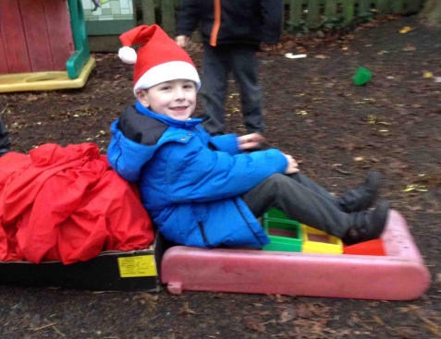 | 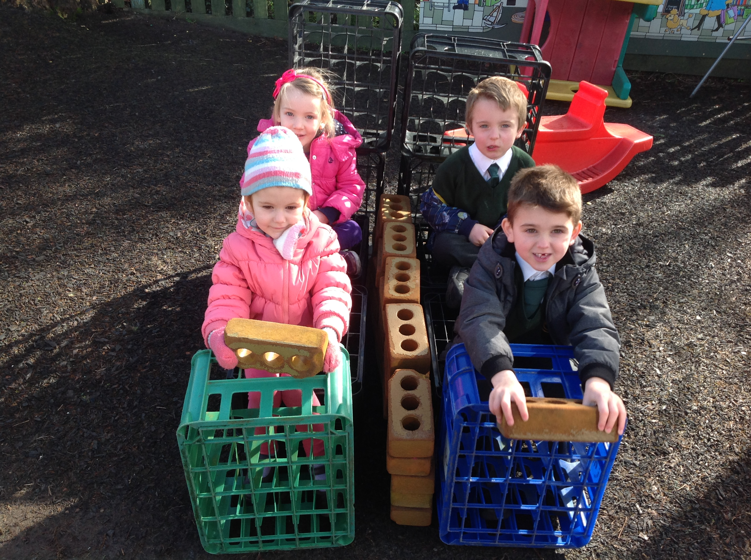
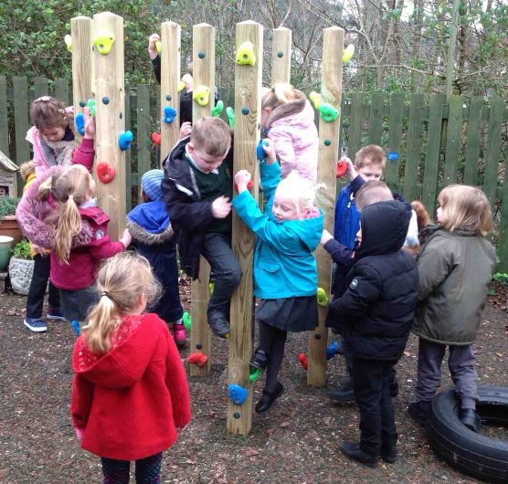 | 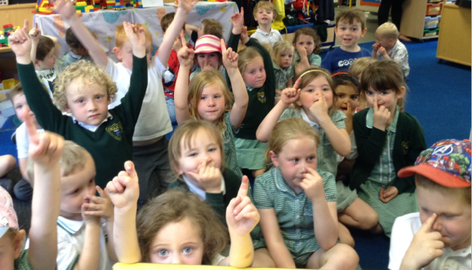

Reception

Reception Induction
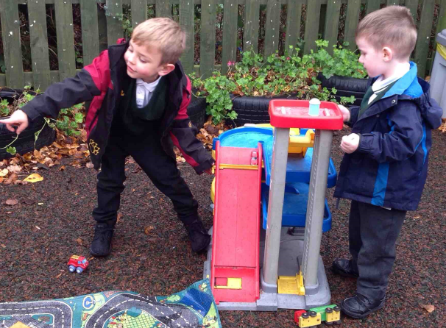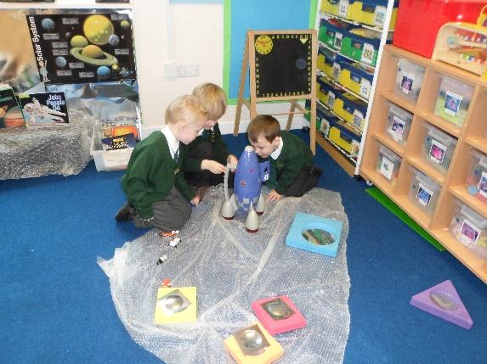

“Living, Loving and Learning Together in God’s Way”

Dear Parents,

We are looking forward to welcoming you and your child to the Our Lady and St Patrick’s Nursery and Primary School (OLSP).

We want this to be the beginning of a happy and successful time for your child and a supportive partnership with you. However, we recognise that starting school can be an anxious time for both children and parents. The aim of this booklet is to provide you with practical information and some useful advice to help make your child’s transition as smooth as possible.

If you have any questions or concerns, please do not hesitate to contact me.

Miss Amy O’Kane
Early Years Reception Teacher
aokane@olsp.uk

Admission and Induction
Most of the children coming into Reception are aware of the unit, the behavioural expectations, the routine and the staff. We hope to make this time full of fun in their learning but also settling them into a longer day.

Any newcomers to the unit will be given plenty of support and reassurances from not only the staff but the children too. New children will be invited for three transition sessions which will get the children used to the routines and behaviour expectations, also allowing the staff to become a familiar face.

Some parents do worry the longer days are a problem for the children and we realise it is a big step for some. We support the children with this and offer quiet times throughout the day.

We recognise children have different needs. If you would like to discuss your child’s induction to Reception any further, please contact Mrs O’Kane, the class teacher.

God Matters
The Catholic Faith and the principles of the Gospel are central to the daily life of Our Lady and St Patrick’s School.
We are committed to:
Living, Loving and Learning Together in God’s Way
Your children will be receiving the highest possible quality of education with a strong ethos of Christian love rooted in the Gospel. We would like everyone who enters into the school to feel welcomed and valued. We will celebrate the uniqueness and giftedness of each individual and everyone involved in the life of the school.
The Foundation Stage Unit builds on your child’s journey with God in partnership with you as parents and carers. We provide the basis for prayer and understanding of the Gospel in order for them to understand this journey.
Your child will join in and learn some daily prayers (copies included in this pack) as well as becoming accustomed to the rituals of Mass and other celebrations. We will follow the ‘Come and See’ RE program which allows the children to discover and learn the way in which Jesus lived and died for us.
The program also leads us into other religions to discover and experience the rich tapestry of world life. We like to think we are globally aware and eager to discover; your child will look at similarities and differences in other cultures, religions and their traditions. This allows early learning behaviours such as reflection and higher thinking skills.
We will be happy to talk through any area of this which you may feel you need to discuss.

Our Special Prayers

The Sign of the Cross
In the name of the Father, and of the Son, and of the Holy Spirit. Amen

Morning Prayer  Father in heaven you love me,  You’re with me night and day.  I want to love you always in all I do and say.  I’ll try to please you Father.  Bless me through the day. Amen.  Grace before Meals  Bless us, O God, as we sit together  Bless the food we eat today  Bless the hands that made the food  Bless us, O God. Amen  Grace after Meals  Thank you, God for the food we have eaten  Thank you, God for all our friends  Thank you, God for everything  Thank you, God Amen | Our Father  Our Father, who art in heaven  Hallowed be thy name;  Thy kingdom come;  Thy will be done on earth as it is in heaven  Give us this day our daily bread;  And forgive us our trespasses,  As we forgive those who trespass against us;  And lead us not into temptation,  But deliver us from evil. Amen  Glory be to the Father  Glory be to the Father,  And to the Son,  And to the Holy Spirit.  As it was in the beginning,  Is now and ever shall be,  World without end. Amen

Night Prayer
God Our Father. I come to say
Thank you for your love today
Thank you for my family
And all the friends you give to me
Guard me in the dark of night
And in the morning send your light. Amen

Learning Together
Being a parent is one of the most rewarding jobs in the world. We believe that you are your child’s first and most important educators.

Learning before school
By this time of year, many children are ready to begin school. They may already have experienced Pre-School education and will have learned many skills and will understand a great deal.

During their first years of life your child has already learned skills that will help them to make a flying start at school:

- Feeling good about themselves
- Listening carefully
- Talking about their thoughts and feelings
- Knowing many stories, songs and rhymes
- Knowing what their own name looks like
- Recognising and knowing about letters and numbers
- Knowing about the different reasons for writing
- Wanting to learn

All these things continue to be important at school, especially the ‘wanting to learn’.
When your child starts school, the support you give them and continue to give them over the years will have an enormous influence on their achievements.

Here are some of the things that will make a real difference right from the start:
- Lots of songs and rhymes
- Listening games
- Playing with shapes
- Drawing and colouring

And perhaps the most important:

- Sharing a book everyday

Making a Flying Start
Getting ready for school
Opportunities
You can provide opportunities for your child to find out, to try new things, to do things successfully.

For example:
- Going out together – talking about experiences
- Helping your child to succeed in something new

Visiting the school together really helps, so that your child knows:
- Where the toilets are
- What the teacher’s name is
- Where to hang his/her coat

Interaction
You can interact with your child by listening, talking, making and doing things together. When your child starts school he/she will need some special attention from you. It helps to make a quiet time at home where you can:
- Listen and encourage
- Talk to each other about what they expect, how they feel, how to behave.

Modelling
Another important influence adults can have on the way that children learn comes from the way children see their adults learning. It helps if your child sees you as people who learn as well as people who know.

Expectations
Because they need the love and support of the adults they live with, children are very much affected by what is expected of them.
If very little is expected, then there is no need for them to try. They may get bored and lack the enthusiasm to try their best.
If too much is expected of them, then children may fail. They are likely to lose confidence and often choose not to attempt something new.

Your expectations need to be not too high, but not too low. It helps to think about what your child can almost do as well as what they can already do.

Recognising effort
Children’s confidence and wish to learn is based on their knowledge of what they can do. When they can nearly do something, a bit of encouragement and enthusiasm can make a big difference. This is much more helpful to children than doing something for them. If they are successful in the end – then the effort is worth making and they will get into the habit of trying hard.

It is, therefore, important that you recognise, value and praise your child’s efforts as well as their skills and achievements. Positive statements can raise your child’s self-esteem and their desire to learn.
“You listened so carefully”
“That’s good writing”
“Well done for trying”

Ready for School?
Your child will be well on their way to being ready for school when they are comfortable with:
- Sharing books
- Communicating well
- Listening carefully
- Talking to other people outside the family
- Respecting and getting on with other people, with good manners
- Asking questions
- Accepting a routine
- Saying what they would like
- Coping with surrounding noise and activity

You can help your child to practise these things at home.

Children find starting school easier when they have:
- Parents who have found out what to expect at the new school
- Parents who encourage their growing independence
- Parents who give reassurance and encouragement

Remember that your child needs to understand that you know and trust the class teacher and the school, that you expect things to go well and that you can talk to the school about any problems.

Carry on helping
One of the best ways for you to help your child do well at school is to take a positive interest in what happens there. When children know their teachers and parents are interested, they are more likely to be successful learners.

This will be important throughout their school lives. Your child will attend school for many years. It will make a big difference if you remember to:
- Keep on doing things together
- Keep on noticing and praising progress
- Keep on talking and listening together
- Keep on being a good example
- Keep on sharing books everyday

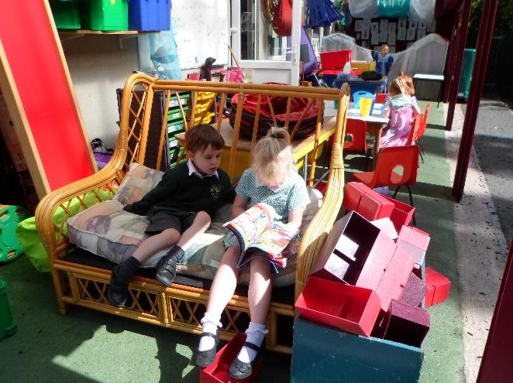

Useful Skills

When your child starts school it would be helpful if he/she could do these things:
Take off coat put on coat and change shoes
and hang it up fasten it

Dress and undress Use a tissue Use a knife and fork

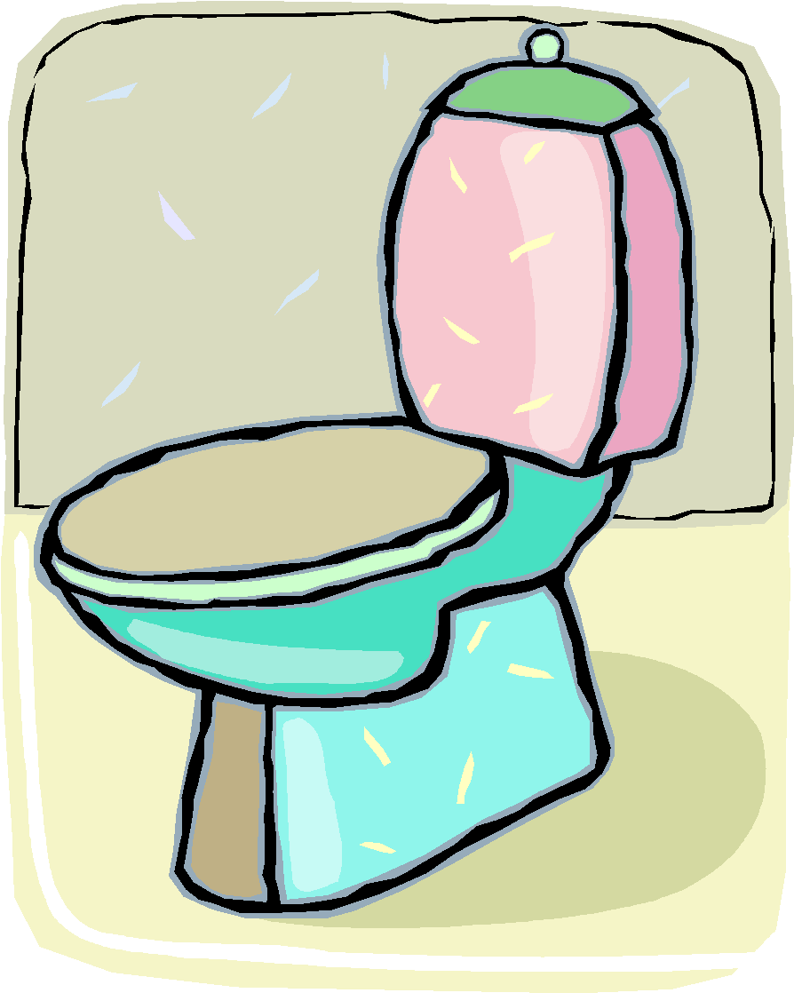 Use the toilet wash and dry share toys and take turns
properly and flush it hands

Help to tidy toys away

P.E. Sessions
The children will have at least two P.E. sessions per week. These may occur at different points during the week. Kit can be left on their peg during the week.

P.E. Kit includes:
- Black shorts
- House coloured T-shirt
- Pumps

Please ensure that all items are named – it helps enormously when getting changed!

Please be aware that jewellery is not allowed to be worn in school and cannot be worn during P.E. lessons under any circumstances.
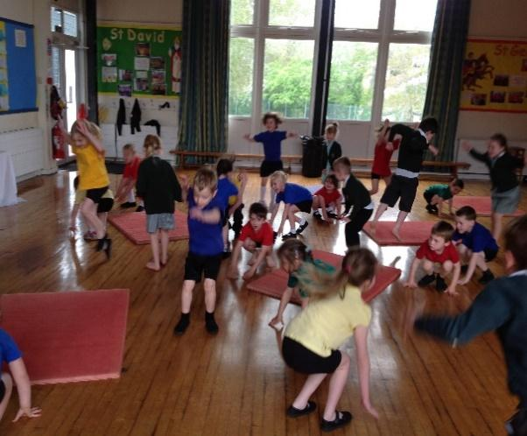

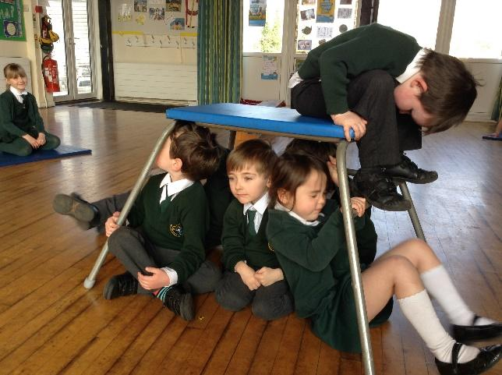

Making a Mark
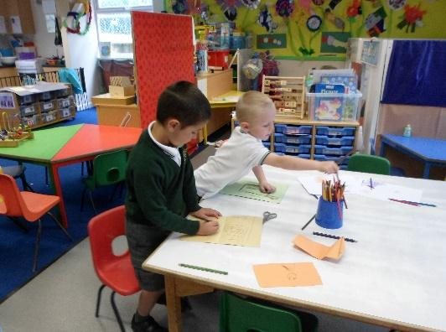
Learning about writing
The process of learning to write is a gradual one which takes a lot of effort and concentration.
Children must learn:
- How to hold their pencil
- How to use the piece of paper
- How to make their marks go in one particular direction
These basic skills help your child to become a fluent and effective writer, especially when they are younger.

Drawing and colouring is an important part of this process, which helps to develop the strength and co-ordination needed to control the pencil as well as confidence in making marks.

For a long time children’s writing will be no more than squiggles and marks. This is a very important first stage of early writing and needs lots of praise and encouragement, BUT during this time they are also developing an understanding:
- That their own names can be written down using these marks.
- That parents can use writing to make shopping lists and send cards and letters.
- That different letters stand for different sounds.
- That they themselves can make shapes that look like writing.
- That the marks have particular shapes and that these turn up in different words.
- That these shapes and marks can be put together to make words to write stories and give messages.

How parents can help
Parents can help by:
- Praising and encouraging your child’s attempts at writing
- Showing an interest in what your child has written. Ask them about it. Join in.
- Listening seriously when they explain what their writing says if they want you can scribe their message next to their own writing.
- Drawing attention to letters and words all around them, eg. Mail through the door. Letters and words in shops, in books, on videos and the television.
- Letting your child watch you writing: reading what you have written to them and telling them who the letters and messages are intended for.
- Encouraging them to add their own writing to your letters, cards, or make their own labels for toys, possessions and friends.
- Looking at alphabet books together
- Making an alphabet scrapbook

Playing with sounds
Books and stories which play with words and rhymes will help children to discriminate between sounds, an important skill for reading and writing. Children love listening to these sounds and rhymes.

Repeated words and phrases can encourage children to join in. Children who have heard a lot of story language will start to use it in their play and in their writing once they start to write their own stories.

Joining the library
Public libraries have many wonderful books for young children and always welcome young members for free. Children have their own library ticket and borrow picture books, story books, information books and CDs. Libraries often have a free story time and special events.
Joining a library early in a child’s life can make a real difference to their later learning.
School Uniform
Please look at the school prospectus to see the uniform list. We have enclosed a leaflet with full details of where to buy our range of uniform.
All children must wear black shoes suitable for the active life in school (no trainers or open toed sandals please). Socks; white, grey or green.
Please ensure that all clothing is permanently labelled with your child’s name.

Medical / Allergies
Ongoing medical issues/Allergies- Please confirm in writing to the school office – we will require a Health Care Plan from the school nurse team for severe allergies (e.g. Epipens).

Administration of medicines
We can administer medicine if required. Please complete the form at the school Reception.

It is the Parent’s responsibility to ensure children attend school. If children are absent we need a Parent signature of some form. If ill, contact the school each morning your child will not be attending with a reason for absence. If planned absence e.g. Drs Appointment; complete and sign S2 absence request form.

If on a school trip, then a parent signature will be requested on the permission slip, unless it is a local trip where you will have completed a walking consent form.

Our Lady and St Patrick’s Catholic Primary School

Answers to frequently asked questions

What things should I keep school informed about?

- If your child has any medical problems or allergies please let us know.

- In the event of sickness please ring the school before 8.30am.

- Any change in emergency telephone numbers, parents address or home telephone numbers should be notified (in writing) to the school IMMEDIATELY in case of an emergency or us needing to contact you.

- If anything changes at home - i.e. family circumstances or arrangements, please let us know.

- If you have any concerns - please make an appointment to see your child’s teacher.

How do I know what’s going on at school?

- Emails are sent out to parents via our school comms with any ad hoc information.

How do we get into the school?

- Please come to the classroom when bringing your child into school in the morning, but at all other times for security reasons, please go via the school office.

- If for any reason you are late (arrive after 8.45am) please enter school via the school office.

- For the safety of your child the car park is for the use of staff only.

Will my child need to bring a snack?

- Throughout the day children have access to milk and water and they are also entitled to receive a free piece of fruit or vegetable as part of the School Fruit and Vegetable Scheme. For additional information please visit http://www.nhs.uk/Livewell/5ADAY/Pages/Schoolscheme.aspx.

- Your child may also wish to bring their own water bottle to drink during their session.

School Dinners?

- In Reception all children are entitled to free school meals. Meals will only be charged when your child moves up to Key Stage 2 (Year 3)

Other Payment Items?

- We can set parents up with a Parentpay account via the school office so please visit the office staff for more information.

How will I be kept informed of my child’s progress?

- There will also be a parents’ evening in the Autumn and Spring terms. If you have any questions or concerns about your child’s progress at any time please do not hesitate to speak to your child’s teacher.

Our Lady and St Patricks

Roman Catholic Primary School and Nursery
Fourth Avenue, Teignmouth, TQ14 9DT

Executive Headteacher: Mrs Cathy Blatchford
Assistant Head / SENDCo: Mrs Rachel O’Sullivan
Website: www.olsp-rc.com
Email: office@olsp.uk
Telephone: 01626 773905

Website address | http://www.olsp-rc.com/web/home/491585
Registration | School is open from 8.30am  All children should be supervised before this time.  Registration is at 8.45am / Collection is at 3.15pm  If you arrive after registration has closed you will need to use the office entrance and a late mark will be given.  KS1  Reception class - drop off and collection please walk children up the main school hill using the pedestrian path and enter and exit through the large green gates just before the school office.  Year 1 / 2 please use the same route as above but continue along the path, passing the nursery unit onto the playground.  KS2 (Year 3 - 6) to enter and exit through the large green gates at the top of the school and to their classroom. At the end of the day children will be walked down by their teacher to greet parents at the bottom of the hill.
Uniform  P.E Kits | Riviera Schooldays  https://rivieraschooldays.co.uk/product-category/schools/schools-our-lady-st-patrick-s-rc-primary-school/  Winter uniform can be worn from after October half term until Easter. Summer uniform can be worn from after the Easter holidays until October half term. Full details are given in the information pack enclosed.  A t-shirt in the colour of their assigned house to be worn in P.E lessons; Yellow (St Davids), Blue (St Andrew), Green (St Patrick), Red (St George).  Second hand uniforms available via our pta ‘The Friends’ at OLSP. Please contact the office for information.
‘The Friends’  OLSP PTA | The Friends are a fabulous team of parents and carers of the children at OLSP. They organise fundraising for the school and bring fantastic activities and opportunities for the children to enjoy. Up and coming events are always shared via our school comms system and facebook. The Friends are always ready to welcome any new parents to help so please contact them directly on friends@olsp.uk or via the office.  Events : http://www.pta-events.co.uk/FriendsOfOlsp  Facebook: http://www.facebook.com/friendsofolsp
Breakfast and After School Club  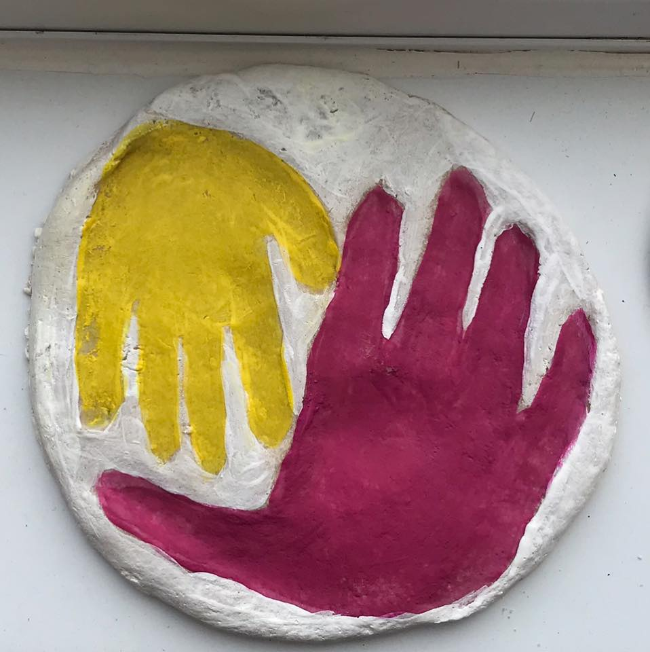 | Jemma Seager Childminding  07557 282469 / jemmaseager@gmail.com  Ofsted registered since October 2020 providing before and after school childcare for children aged from 3-11 years who attend Our Lady & St Patrick RC Primary, Teignmouth.
School Comms | Most information and letters are sent out electronically via School Comms.  We send out newsletters fortnightly on Monday’s and also forms and news about events and activities.
Class DoJo | Class Dojo - this is a great way for teacher and parent to communicate. Any class reminders and announcements will be posted and parents can communicate non urgent messages.  Download the app or open in a web browser. Sign up as a parent and add your child/ren. Class Teacher will send a unique code to join.
Classroom | Your child/ren will be given various logins by their class Teacher. These platforms will be used to track learning in class and can be used to set homework. If your child does not have access to a device at home please speak with their teacher.  Google Classroom  IXL Maths and English online (Year 1 and above)  TTRS - Times Table Rock Stars (Year 1 and above)
Parentpay | We use Parentpay for payments for trips, activities, lunch payments etc.  Once your child is on roll we will issue you an activation letter to enable you to set up your account. This is a convenient and quick way to pay for items. Please contact the office office@olsp.uk for more information about Parentpay.
School Meals | Children in Reception, Yr 1 and 2 receive universal free school meals and no payment is required. You can of course choose to send your child in with a packed lunch if this is preferred.  To purchase meals for Key Stage 2 (Yr 3 and over) please do via Parentpay. Each meal is £2.65. We advise you pay 1 week in advance to avoid debt. Alternatively your child can bring a packed lunch. Lunch choices are collected each morning by the teacher.  Menus are published on the website – go to Parent’s Links.
Free School Meals | Do I qualify for free school meals?  All children in reception, year 1 and year 2 at schools in England automatically get free school meals. However, parents and guardians are encouraged to still apply for free school meals when they enrol their child in school, as this can help their child’s school to attract additional ‘pupil premium‘ funding to support learning.  Children whose parents are in receipt of the following are entitled to free school meals:  - Income Support  - income-based Jobseekers Allowance  - income-related Employment and Support Allowance  - support under Part VI of the Immigration and Asylum Act 1999  - the guaranteed element of State Pension Credit  - Child Tax Credit (provided you’re not also entitled to Working Tax Credit and have an annual gross income of no more than £16,190)  - Working Tax Credit run-on – paid for 4 weeks after you stop qualifying for Working Tax Credit  - Universal Credit.  - Children who receive any of the above benefits in their own right (i.e. they get benefits payments directly, instead of through a parent or guardian) can also get free school meals.  How to apply:  Go to https://oneonline.devon.gov.uk/CCSCitizenPortal_LIVE/en and create an account or log in to your existing account.  Parents and carers can also ring the Education Helpline on 0345 155 1019.
Sickness | If your child is sick please contact the school on the first morning of illness and each day that they are sick to avoid an unauthorised absence mark.  Contact:  01626 773905 and leave a message on the absence answerphone (option 1). Alternatively you can e-mail office@olsp.uk  Please ensure you give full details of the circumstances.
Other absences | If you need to request an absence for your child/ren you must complete an absence request form (S2) and submit it to the school. You can find an electronic form on the website under Parent’s Links. Alternatively visit the school office.

We would appreciate paperwork enclosed with this pack being sent back to the Office asap so that we can ensure our records are updated.

