Our Lady and St Patrick’s RC Primary School

Autumn 1 Curriculum Newsletter

Class 3

 | Teacher’s Message | Hello All and a huge welcome to year 3. Hope you all had a lovely summer and are rearing to get back. I’m really looking forward to this year. I’m so pleased to continue to be the Class 3 teacher with an amazing bunch of children. I really can’t wait to get back into the classroom and get some quality learning done.
 | Homework | Set on Google Classroom:  Spellings: Weekly spellings are set home each Friday. Each week, the children receive a list of 10 words which will focus on practising new spelling rules.  - Weekly spelling tests take place on Fridays.  - Please make sure children are practising spellings daily where possible.  Children should also bring home their AR books and reading journals from school and try to read daily for at least 5 minutes. They can then quiz on these in school.
 | Reading for Pleasure | We will be Starting the year by reading through my favourite book, Mr Penguin and the lost treasure by Alex Smith. Can not wait to share it.  ‘Meet Mr. Penguin: adventurer. He has a dashing hat. A battered satchel. And a kung-fu spider sidekick. Now he just needs an adventure!’ The children have really been enjoying listening to the puzzles and clues in the story and Colin saving Mr Penguin all the time..  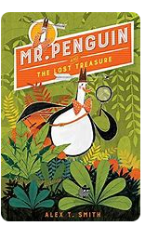
 | English | In English, we will be looking at a story called Elf Road which is a portal story by Pie Corbert. We will be dissecting it for use of setting descriptions using expanded noun phrases and prepositions for adverbial phrases all leading to writing our own portal story.  Our non fiction text will be ‘Interview with a Tiger’ where the children will be researching and pretending to interview an animal while using specific vocabulary to impose a personality on the animal. Looking forward to some funny results.
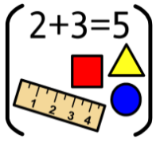 | Maths | In our maths lessons this half term we will be learning about place value to 3 digits and looking at adding and subtracting 3 digit numbers through partitioning.
 | RE | In RE, we will be following the new Religious Education Directory (RED). This term is all about Creation and Covenant.
 | Science | In Science we are learning all about animals and humans including things like how we get our energy, the relationship between bones and muscles and all the differences in skeletons that animals and humans possess.
 | Geography | Not a lead subject
 | History | During History this term, we will be looking at the stone age to the iron age and looking at how the developments of technology over time shaped our current civilisation today.
 | Art | In Art this term, we will be looking at painting and how particular artists use different brush strokes and colours to convey meaning and emotion. This will all culminate in a final art piece which takes inspiration from Jackson Pollock. It is going to get messy.
 | Design Technology | Not a lead subject
 | RSHE | In RSHE, we are learning about staying safe and how we can look after ourselves linking to concepts of nutrition, hygiene, online activity, mental health and safety around our environment (fireworks, sun, water).
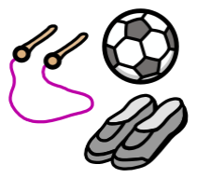 | PE | In PE this term, I will be teaching ball related skills which will culminate in team related games. Mr Selley from Premier Education will be teaching touch rugby.
 | Computing | Computing this term is all about Online safety. Supporting the children in understanding how to search the internet appropriately, what to do if they are worried about something they have seen and being on the lookout for scams and fraudulent emails. .
 | Spanish | In Spanish, children will be taking their first steps on their journey to learn how to speak basic Spanish: simple greetings and conversation, months of the year and days of the week.
 | Music | Music will be covered by Mr Hopkins, our new music teacher. The children will be learning the fundamentals of creating music with and without instruments.
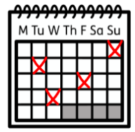 | Upcoming dates/events | 6th September - Return to school  9-12th October - Provisional dates for Kents Cavern trip
 | Teacher contact: | jmason@olsp.uk  Please note that teachers are teaching from 8.30am - 3.15pm. If your contact is urgent please contact the school office office@olsp.uk during the school day.  There is no requirement for a teacher to reply to email or class dojo messages received after 6pm or at the weekend.

