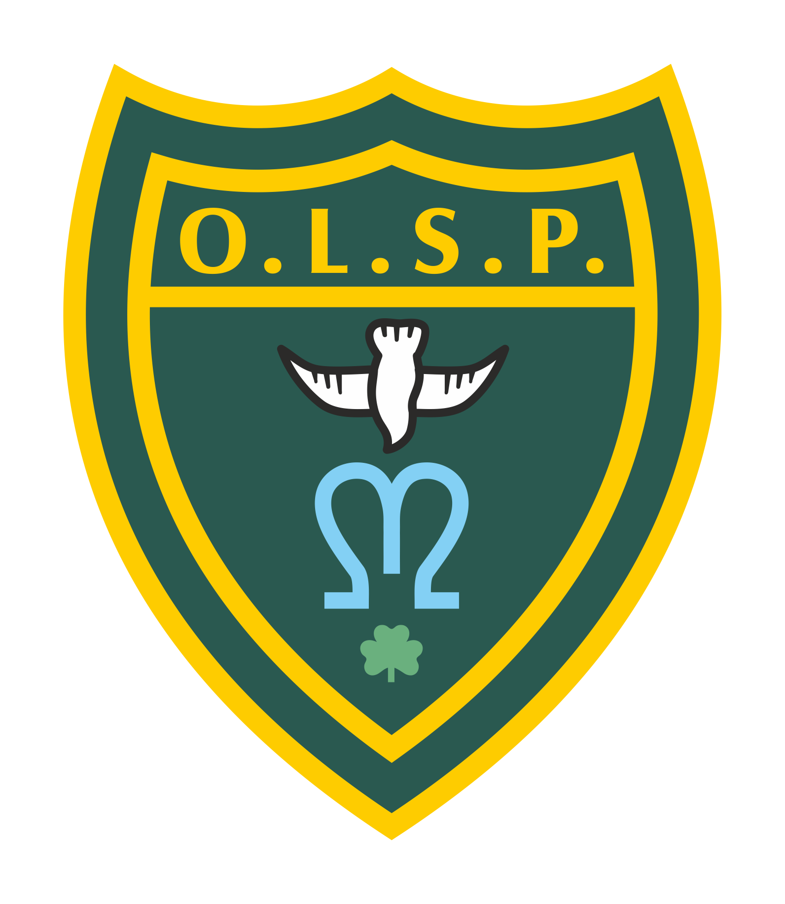
Our Lady and St Patrick’s RC Primary School

Half Termly Curriculum Newsletter

Class: Stars and Moons Autumn 2

 | Teacher’s Message | We hope you all had a wonderful week. We are really looking forward to hearing what all the children got up to during their break. We have a very busy half term coming up with lots of exciting things planned.
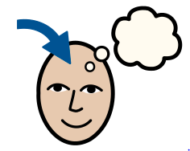 | Homework | We will be starting our phonics journey as soon as we return. Please encourage the children to review their sounds. You can ask them “What is your sound of the day today?”  “How do you write that sound?”  We will also be focusing on name writing and number formation. You will also be receiving formation sheets coming home with your children to really focus on what the sounds look like.
 | Reading for Pleasure | The children will be continuing to vote for the end of the day stories. The book corners will have all the books refreshed and rotated to encourage the children to explore a variety of texts.
 | Reading | We will be reading regularly in class this half term focusing on stories and storytelling and we will begin to include some poems.
 | Literacy “Drawing Club” | During drawing club we look at stories, traditional tales and animations. This half term we will look at the Room on the broom, The magic porridge pot, Captain Pugwash, Where the wild things are, The Gingerbread man and The Christmas pine. We learn new vocabulary and think about different elements of the story before creating our ideas and writing about them.
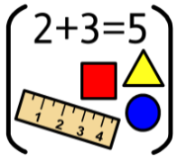 | Maths | In Maths we will be looking at number bonds within 5, shape and space, numbers to 10 and comparing numbers within 10.
 | RE | In RE we will continue our learning journey looking at Prophecy and Promise.This will be looking in detail at how people prepared for Jesus’ arrival and what they did to prepare. We will be exploring how people celebrate Christmas around the world.
 | Science | In Science we will be looking at everyday materials. We will be looking at how things work and learning the qualities of materials and why they were chosen for certain jobs.
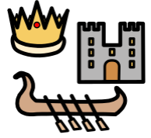 | History | Not a lead subject this half term
 | Geography | In Geography we will be investigating different celebrations around the world. We will be exploring if Christmas is celebrated in the same way around the world.
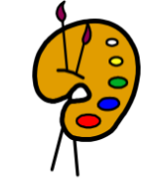 | Art | Not a lead subject this half term
 | Design Technology | In Design Technology, we will be looking at how things work? We will be exploring ways to join different materials. We will also be looking at simple mechanisms then creating our own moving part cards.
 | RSHE | The children will be looking at different scenarios matched to the children's ages and will be discussing how to deal with them and manage them in the best possible way. For example, if you accidentally rip a school book what should you do? Or your friend is away poorly and you really wanted to play with them. What could you do instead?
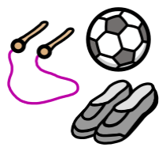 | PE | During PE sessions we will be engaging in structured movement through the topic of 'everyday life'. The children will spend time learning basic principles of a PE lesson such as safely using space, stopping safely, using and sharing equipment and working individually, with a partner and group. They will take part in activities which will develop fundamental movement skills such as running, jumping and skipping. Children will also play simple games and begin to understand and use rules.
 | Music | Children will develop their listening skills in Music and they will start to share their opinion of different genres of music. We will also be working on our nativity songs ready to dazzle you during our performance.
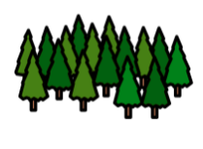 | Welly Walks / Forest School | Welly walks will continue this half term.
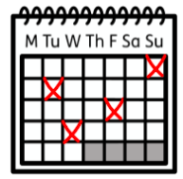 | Upcoming dates/events | 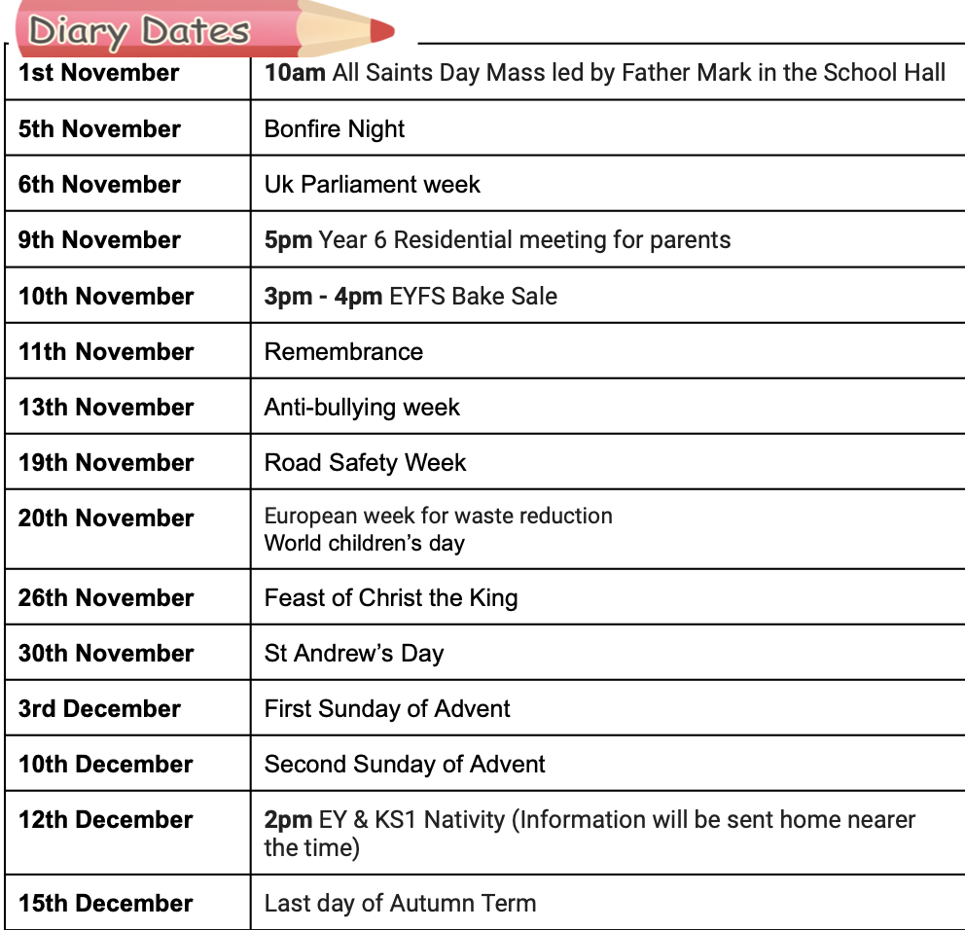
 | Teacher contact: | aokane@olsp.uk  Please note that teachers are teaching from 8.30am - 3.15pm. If your contact is urgent please contact the school office office@olsp.uk during the school day.  There is no requirement for a teacher to reply to emails received after 6pm or at the weekend.

