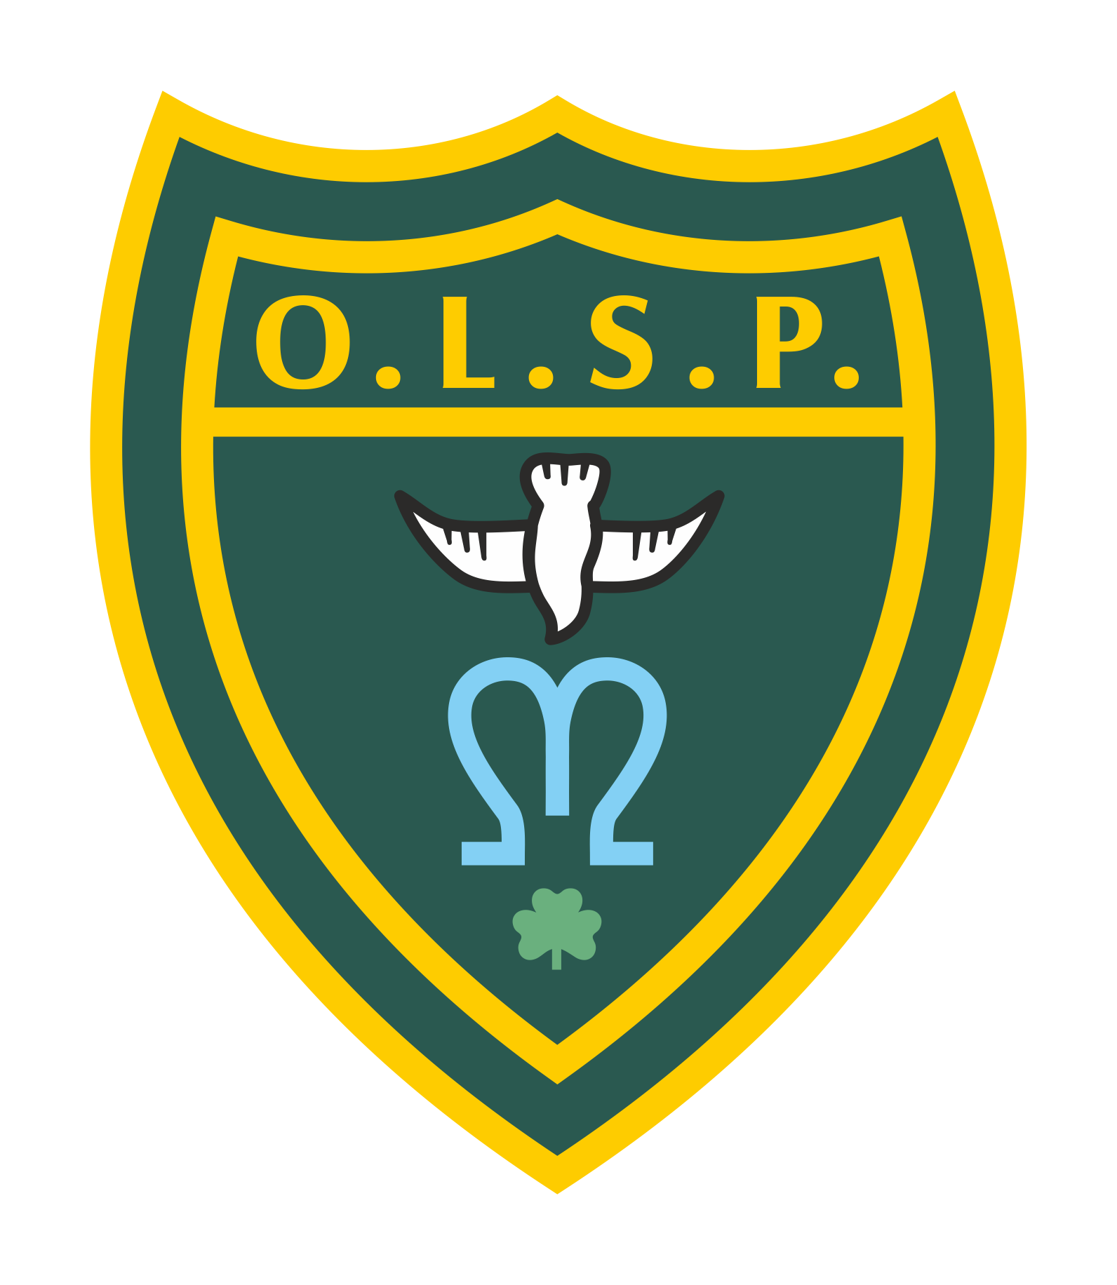
Our Lady and St Patrick’s RC Primary School

Half Termly Curriculum Newsletter

Class: Stars and Moons Autumn 1

 | Teacher’s Message | We hope you all had a wonderful summer break. We are really looking forward to hearing what all the children got up to. We have created lots of new areas for the children to explore and have some exciting learning opportunities planned for them. We can’t wait to get started.
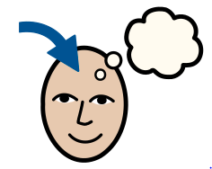 | Homework | We will be starting our phonics journey as soon as we return. Please encourage the children to review their sounds. You can ask them “What is your sound of the day today?”  “How do you write that sound?”  We will also be focusing on name writing and number formation. You will also be receiving formation sheets coming home with your children to really focus on what the sounds look like.
 | Reading for Pleasure | The children in class will notice a few changes to our areas especially our new themed book corners where the children can relax and enjoy a book.
 | Reading | We will be reading regularly in class this half term focusing on stories and storytelling.
 | Literacy “Drawing Club” | During drawing club we look at stories, traditional tales and animations. This half term we will look at the Colour Monster, Farmer Duck, Three Billy Goats Gruff, Little Red Hen and our animations will be Trap door and Road runner. We learn new vocabulary and think about different elements of the story before creating our ideas and writing about them.
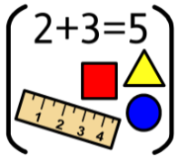 | Maths | In Maths we will be looking at numbers to five and comparing groups within 5. We will also be working on our number formation focusing on a different number daily.
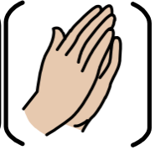 | RE | In RE we will begin our learning journey with the story of creation. We will understand how God created the world and the importance of prayer and what makes us special and unique.
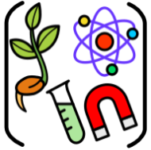 | Science | In Science we will be looking at animals including humans. Our learning question to explore will be what makes me me? We will learn about things that make us unique. We will begin to talk about some similarities and differences in relation to friends or family. We will also start discussing observations we have made on our environment.
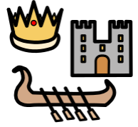 | History | Our history also links nicely with science where we will be learning all about ourselves and our families. We will discuss different stages of our lives and our history within our family.
 | Geography | Not a lead subject this half term
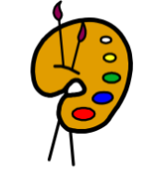 | Art | In art we will be looking at creating with different mediums. This half term we will be focusing on paint. Exploring different types and techniques to use the paint. We will then create self portraits.
 | Design Technology | Not a lead subject this half term
 | RSHE | In our PSHE sessions we will look at two key questions: the 1st is how to be a good friend? We will be working on children playing cooperatively, turn taking and sharing.  The second is How can we play safely? We will be looking at different areas of the classroom and establishing the expectations of the children in those areas. We create our own class rules as well as ensuring children are familiar with the school rules. We will also cover road safety, firework safety and stranger danger.
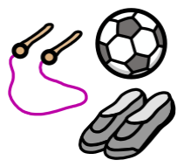 | PE | We will begin establishing a routine of changing and settling and then we will be practising a variety of movements through games and showing consideration to others.
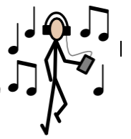 | Music | In music we will be learning lots of nursery rhymes and rhythms taking time to learn good listening skills and to take turns and share ideas and opinions. We will also be learning some songs to share with you for harvest.
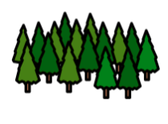 | Welly Walks / Forest School | Welly walks will commence in the second week of term once all the children have settled into the new routines and structures of their days.
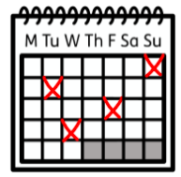 | Upcoming dates/events | 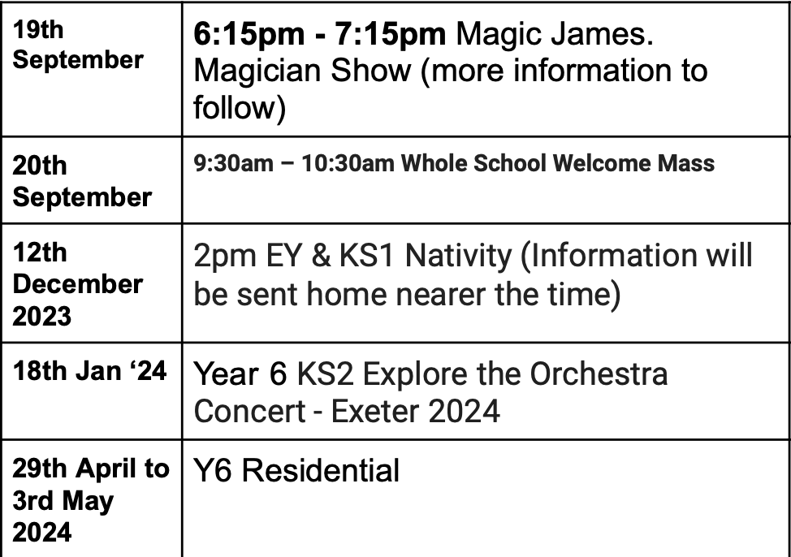
 | Teacher contact: | aokane@olsp.uk  Please note that teachers are teaching from 8.30am - 3.15pm. If your contact is urgent please contact the school office office@olsp.uk during the school day.  There is no requirement for a teacher to reply to emails received after 6pm or at the weekend.

