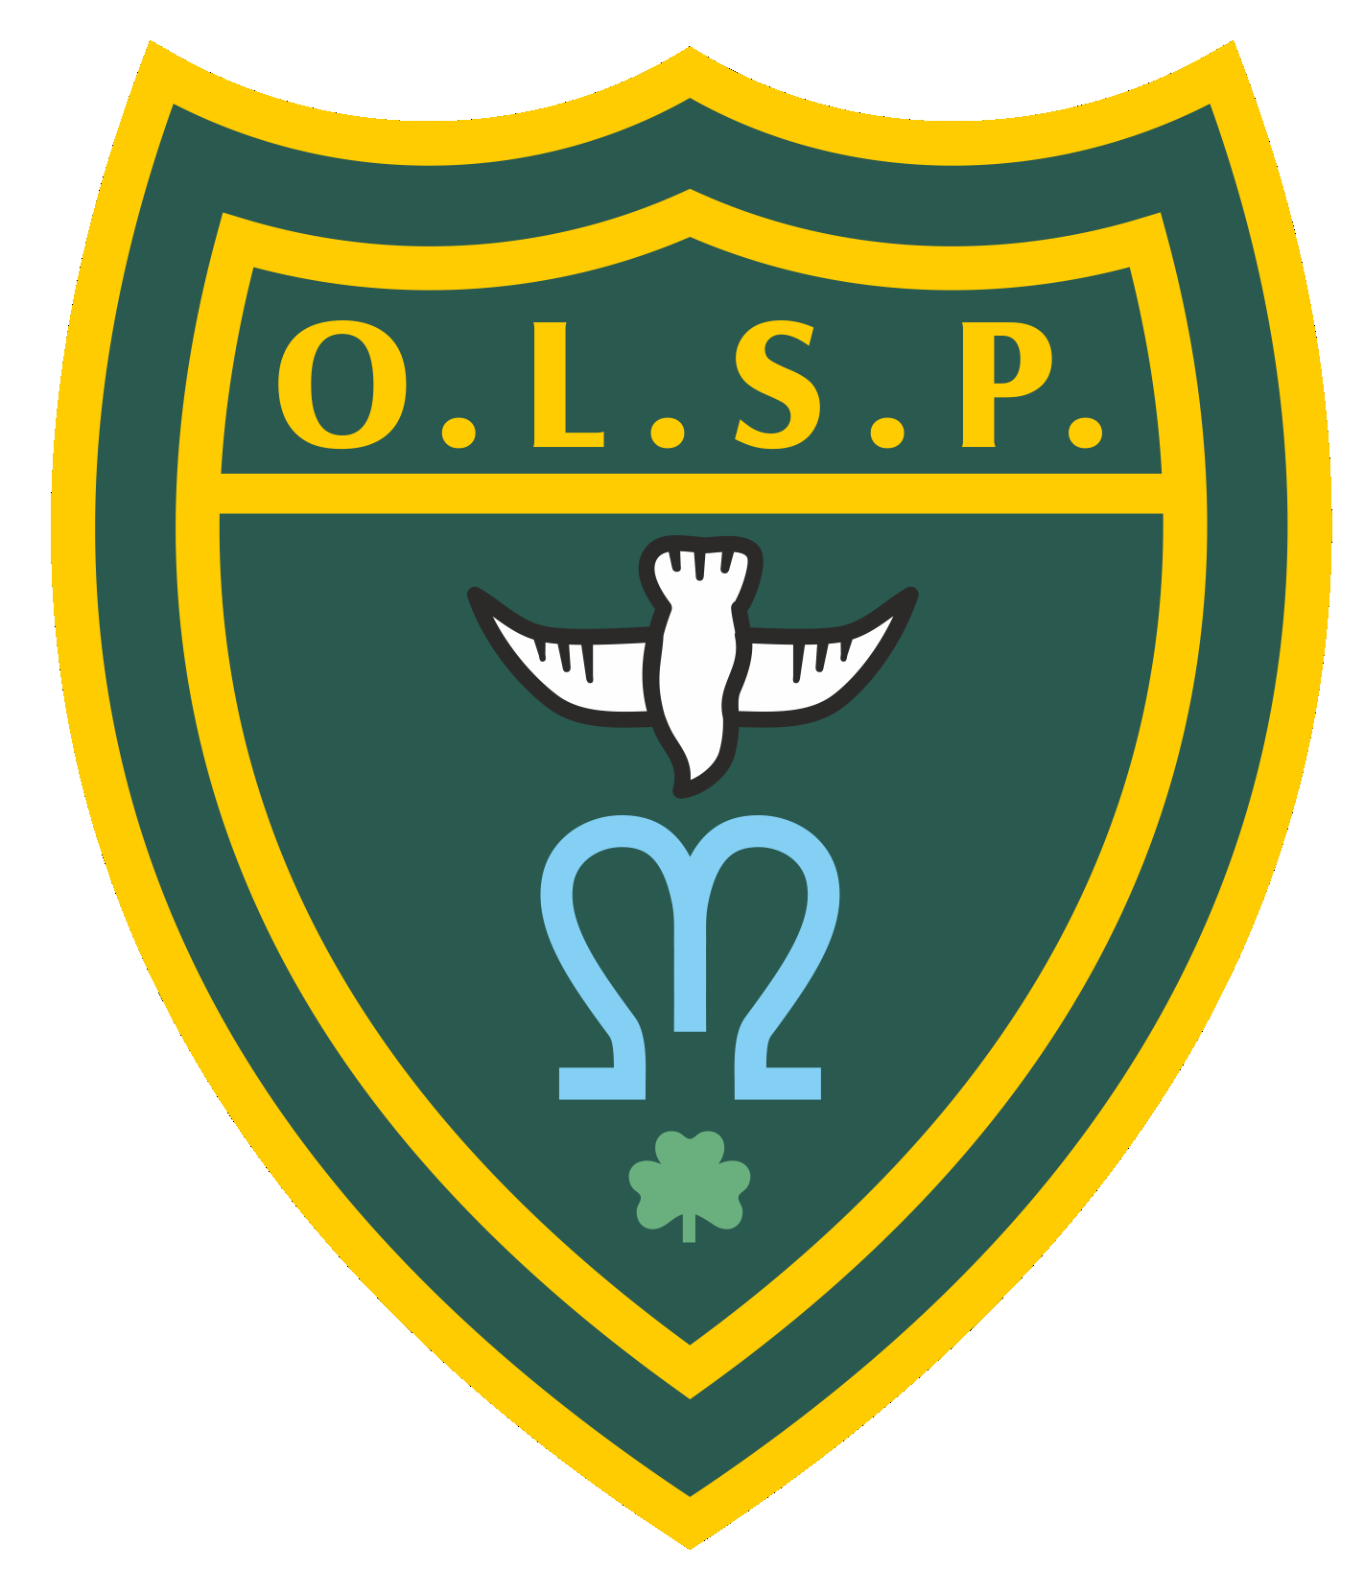
Our Lady and St Patrick’s Roman Catholic
Nursery and Primary School
Fourth Avenue, Teignmouth TQ14 9DT
Tel: 01626 773905
e-mail: office@olsp.uk
Head Teacher: Miss Cathy Lowry

Administration of Medicine Agreement in School
Name of Child |  |  |  |  | Class
Ailment

Name of Prescribing or advising Doctor

Medicine

Dose | Time to be administered  (Please circle) |  | 12.00 noon
Number of days to be administered for |  | OR |  | Until course is complete  (Please tick)
I confirm that the above medicine has been prescribed by a doctor, and I give my permission for the Head Teacher (or her nominee) to administer the medicine to my son/daughter during the time has/she is at school.

Signed
(Parent/Carer) Date

Name
(Please print)

I confirm that the above medicine has NOT been prescribed by a doctor, however I hereby give consent, after advice from a doctor, for the Head Teacher (or her nominee) to administer the medicine to my son/daughter during the time has/she is at school.

Signed  (Parent/Carer) |  |  |  |  |  | Date
Name
(Please print)

NOTES OF GUIDANCE

- The Head Teacher (or her nominee) will only administer medicines prescribed or advised by a doctor.
- This form should be completed by the parent or carer of the child and be delivered personally, together with the medicine, to the school office.
- The medicine should be in date and clearly labelled with:

  - its contents;
  - the owners name;
  - dosage;
  - the prescribing or advising doctor’s name.

- The information given above is requested, in confidence, to ensure that school staff are aware of the medical needs of your child.

While no staff member can be compelled to give medical treatment to a child, it is hoped that staff will see this as part of the pastoral role and duty of care. Where such arrangements fail it is the parent’s responsibility to make appropriate alternative arrangements.

