Instrumental Lessons with Mrs. Price

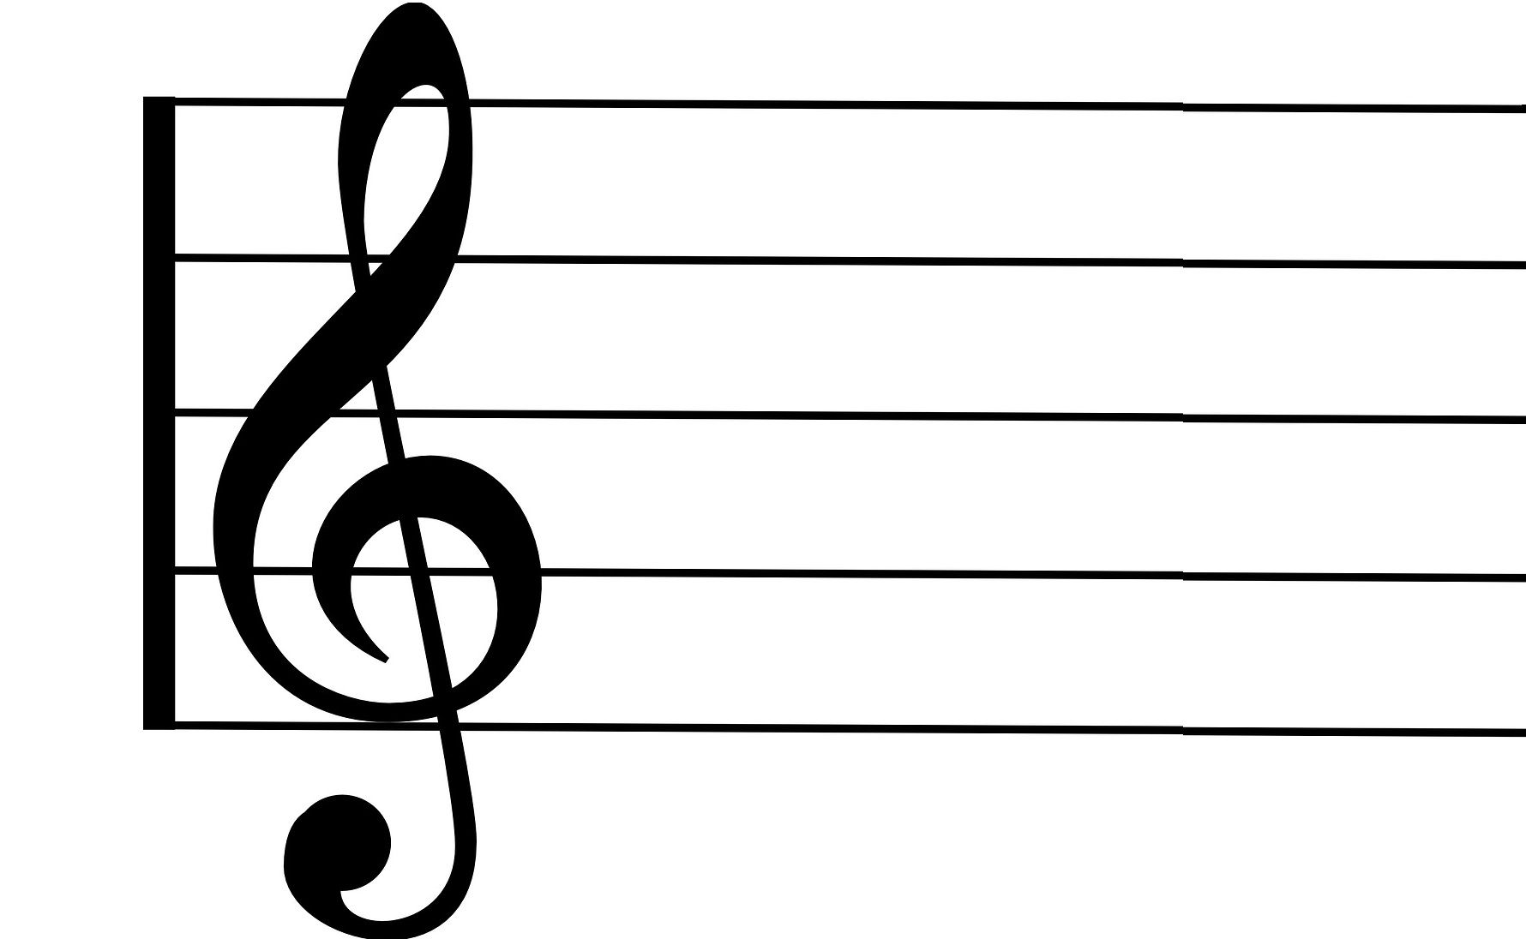
Trumpet / Cornet / Baritone / Pbone /Trombone / French Horn / Tenor Horn / Clarinet / Recorder / Piano

Mrs Lisa Price
Mobile: 0779 625 7788
E-mail: lisapteach1@gmail.com

Dear Parent / Guardian,

I am an experienced instrumental teacher and I would be very happy to provide lessons for your child.

The number of lessons will vary according to the length of each term (normally 10 or 11). Lessons will be 20 minutes long. Shared lessons are only available if there are enough pupils to create these opportunities.

All fees are payable in advance at the beginning of the term of lessons. If your son / daughter wishes to stop lessons, a half term’s notice will be required in writing.

Lessons on days of any planned school trips or authorised absences will need to be re-arranged well in advance, but any absence due to illness of your son / daughter or for any other reason will be charged, although every effort will be made to re-schedule the lesson. Lessons missed as a result of my absence will, if possible, be made up during the same term or credited to the following term’s account. I am happy to give a termly update of your son’s or daughter’s progress, if you wish.
Practice between lessons is expected, so please encourage him / her to practise regularly.

Please email me if you are happy for your son / daughter to start lessons with me.

Lisa Price.

School ___________________________________________

Child’s name ______________________________________ Year Group ________

Email address ______________________________________________________________________________

Parent / Guardian name ____________________________________________________________________

Mobile number ____________________________________________________________________________

Home address (incl postcode) _____________________________________________________________

Preference: (please circle) Trumpet / Cornet / Baritone / Pbone/Trombone / French Horn / Tenor Horn / Clarinet / Recorder / Piano

Lesson costs: 20 minute individual lesson each week £11

I would like my son / daughter to receive tuition.

Signed ___________________________________ Parent / Guardian Date __________________________

