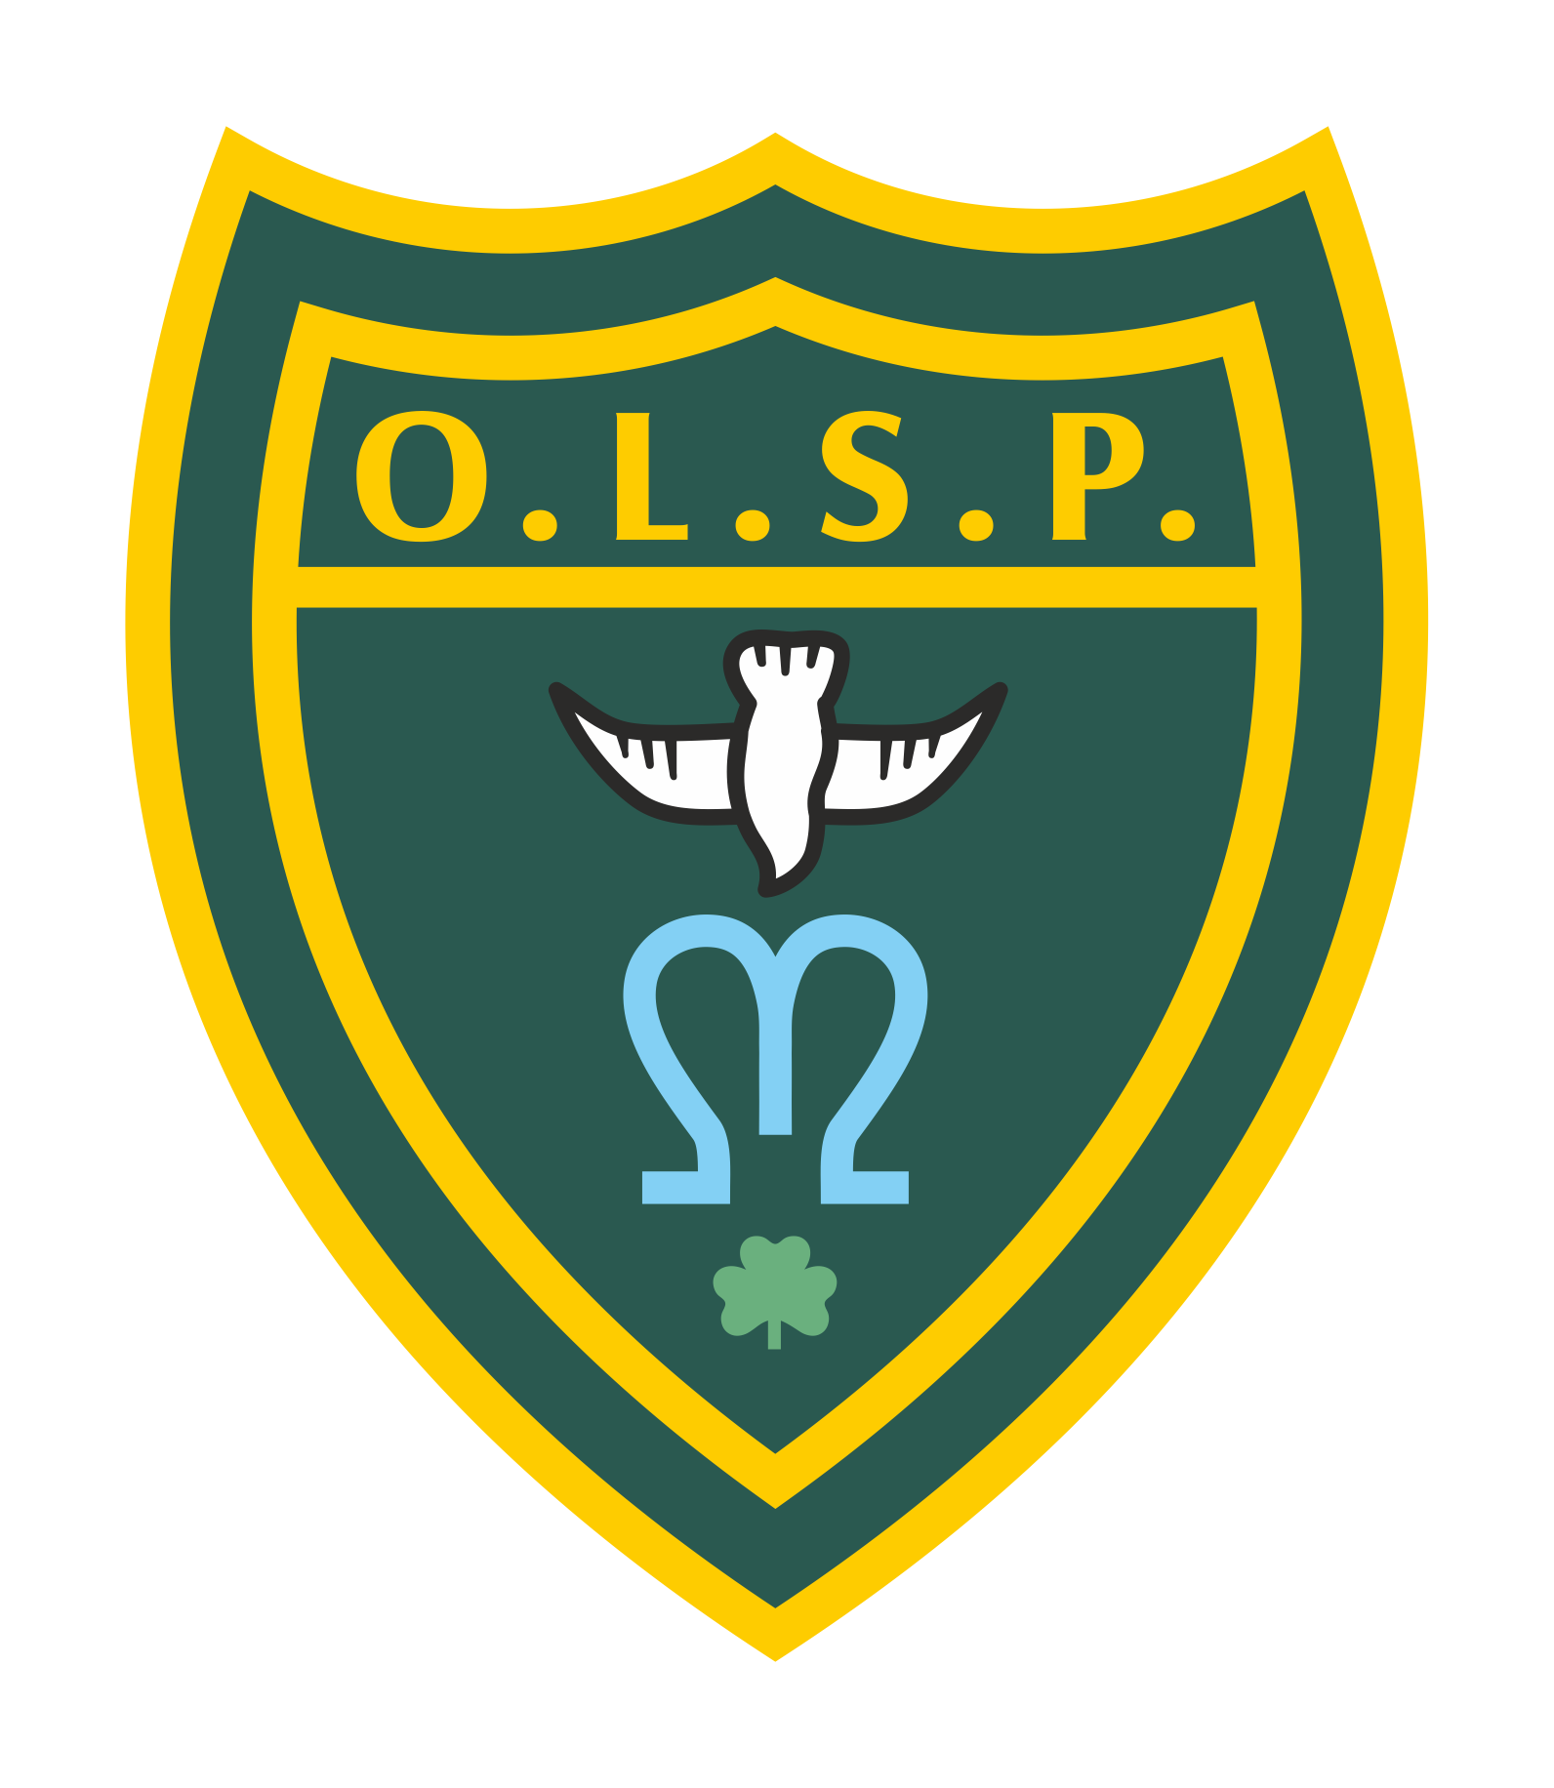
Our Lady and St Patrick’s RC Primary School

Half Termly Curriculum Newsletter

Class: EYFS Spring 2

 | Teacher’s Message | We hope you all had a wonderful break. We have another busy half term planned for EYFS. The children have particularly enjoyed our learning about superheroes. I think we know everything you need to know about being super! I’m really excited to see how they enjoy our next theme of pirates.
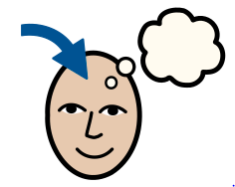 | Homework | We have very much started our phonics journey. Please encourage the children to review their sounds. You can ask them “What is your sound of the day today?”  “How do you write that sound?”  We also use the phonics play website for phonics games and top marks maths for maths games.  During this half term the reception children will be getting to grips with iXL you will receive your child's individual logins at parent evening
 | Reading for Pleasure | Please continue to share lots of stories with your children. Consider a variety of texts like some non fiction fact books alongside some traditional tales. The children have enjoyed showing us their reading records too and talking about their favourite books. We have now got a class login to Oxford Owl to support your child's reading. Username eyfsaok Password OxfordOwl
 | Reading | We have requested a topic box from the library this half term to support our pirate themed learning. There we will have some stories, songs and non fiction texts that we hope the children will enjoy. Our class author is Jonny Duddle who wrote some brilliant pirate books like the pirates next door.
 | Literacy | We will be linking our learning to our Geography topic of explorers. Our first focus will be writing a list of things we need to be good explorers, then moving on to planning an expedition before going on an expedition and writing about what happened.
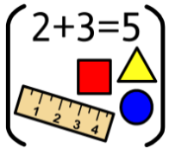 | Maths | In Maths we will be continuing to look at number bonds to 10, before looking at subtraction within 10 and exploring patterns.
 | RE | Our focus in RE this half term is gathering. Looking at why people gather together and different occasions and opportunities for gathering.
 | Science | In Science we will be focusing on plants. We will be looking in our school environment at the plants around it. We will attempt to sow our own seeds and grown flowers and vegetables looking at the structure and parts of the plants.
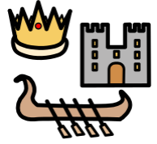 | History | Not a lead subject this half term.
 | Geography | In geography this half term we will be learning about our local area and its uses in the community. Towards the end of the half term linked to our english we hope to go out to explore some of the areas nearby.
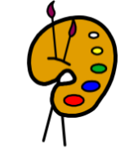 | Art | Not a lead subject this half term.
 | Design Technology | Our topic area will be construction. We will be looking at different ways to join a variety of materials together, we will have weekly opportunities to engage with junk modelling and designing things with a purpose.
 | RSHE | In these sessions children will be discussing our feelings and behaviour and how we can ask for help but also find ways to manage them ourselves.
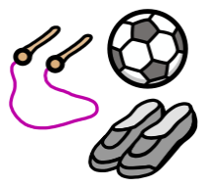 | PE | In PE we will be doing dance, looking at movement and creating a routine within a group.
 | Music | Music lessons will be focussing on songs that tell a story and will be helping us hone our listening skills.
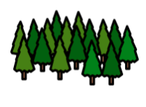 | Welly Walks / Forest School | Continuing every Thursday- children are to come in in their own clothes with school uniforms in bags.
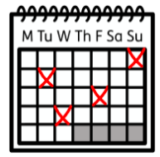 | Upcoming dates/events | 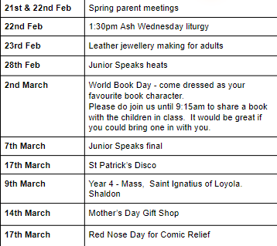  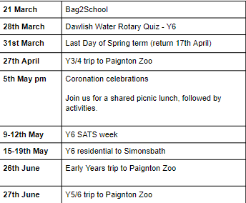
 | Teacher contact: | aokane@olsp.uk  Please note that teachers are teaching from 8.30am - 3.15pm. If your contact is urgent please contact the school office office@olsp.uk during the school day.  There is no requirement for a teacher to reply to emails received after 6pm or at the weekend.

