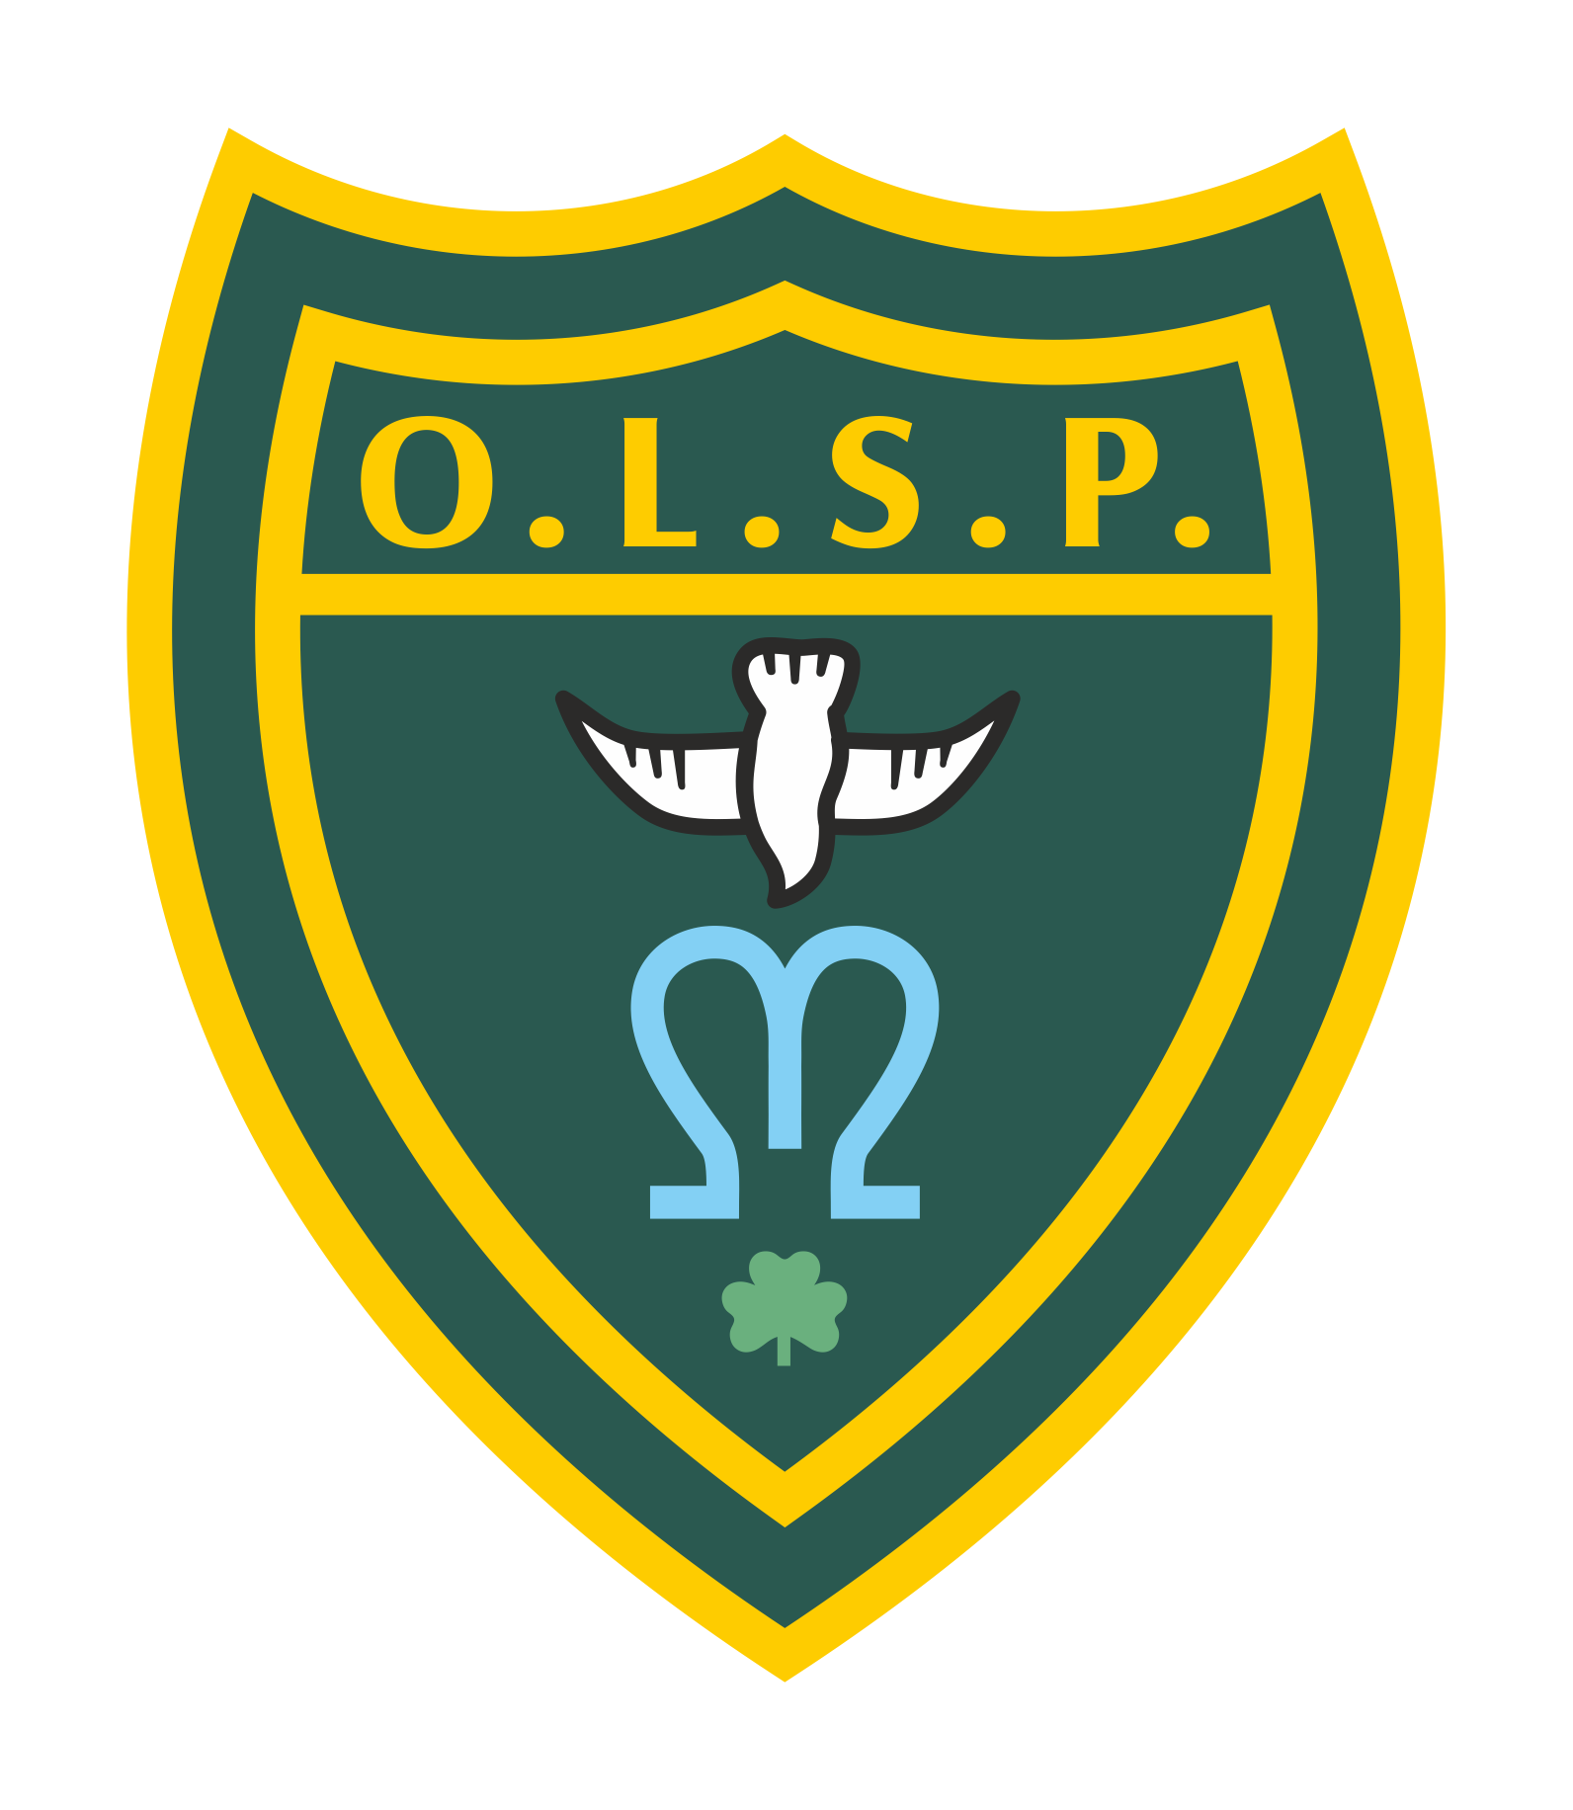

| **Our Lady and St Patrick’s RC Primary School**  **Half-termly Curriculum Newsletter**  **Class 6~Supernova Summer 2 2025** |
| --- |

|  | **Teacher’s Message** | We hope you all had a lovely half-term break and managed to enjoy the sunshine!  As we head into this final (and very busy!) half-term for our Year 6s, we wanted to share some key dates with you. We will also continue to keep you updated through Class Dojo as much as possible.  9th June - start of weekly swimming sessions  6th June - TCS transition visit to OLSP  11th June - AM - Enhanced transition for selected pupils at TCS   * PM Junior Speaks Heats   12th June - Y5/6 Tri golf festival at TCS  12th & 19th June pm- Forest school activities (change of clothes needed)  19th June - Civic Award Assessment Date  20th June - School BBQ  24th June - NSPCC workshop  25th June - Sports Day  26th/27th June - Teign School transition day  1st July - Pilgrimage Walk  2nd July - Plymouth CAST leavers Mass - Torquay  3rd July - TGGS & TBGS transition day  8th July - TCS transition day & SATs results  9th July - Civic Award presentation evening  14th July - Beginning of ‘Enterprise Week’   * Dress rehearsal for school - Charlie and the Chocolate factory   15th July - Evening performance to parents of Charlie and the Chocolate factory.  16th July - potential attendance award to Splashdown.  18th July - Y6 v staff football match  21st July - Enterprise selling event  22nd July - 9am Leavers Mass at OLSP church - parents invited   * pm Y6 water fight   23rd July - 9:15am Leavers assembly - parents invited |
| --- | --- | --- |
|  | **Homework** | This half-term, homework will focus on learning the playscript and songs for our upcoming performance, as well as making sure all evidence is gathered to complete the Year 6 Civic Award. However, it’s really important that children continue to maintain good reading habits — *they should aim to read for at least ten minutes every evening.* |
|  | **Reading for Pleasure** | This half term we will be reading Sky Chasers by Emma Carol. |
|  | **Writing** | We will be using our new text (Sky Chasers) as a stimulus for learning how to:  • Recognise vocabulary and structures for formal speech and writing, including subjunctive forms  • Identify the audience for and purpose of writing  • Choose the appropriate register  • Use semi-colons, colons or dashes to mark boundaries between independent clauses  • Use language carefully to influence the reader’s opinion of a character, place or situation  • Use powerful and varied verbs for action  • Use paragraphs to vary pace and emphasis  • Use dialogue to explain the plot, reveal new information, show character or relationships or to convey mood  • Combine action, dialogue and description |
|  | **Maths** | We will continue to build on arithmetic fluency completing daily tough ten. The children will continue with work started last half term, being maths buddies for our year 3, knowing that the greatest way to consolidate understanding is being able to teach it to another. We will also be carrying out project work including Enterprise Week. |
|  | **RE** | The unit this half term is called ‘Dialogue and Encounter’. The children will be learning about the life of St Paul and why he is an important figure for christians. They will be exploring reasons why there are different liturgical traditions in different parts of the world. They will be learning how to describe the five pillars of Islam and why they are an important part of Islamic faith and religious practice for British Muslims today. |
|  | **Science** | This half term our unit is ‘Electricity’. The children will be working on a combined Science and DT unit whereby they have the task of creating a security system to protect something valuable that is coming to Teignmouth for exhibition. |
|  | **History** | This term we will be studying ‘Crime and Punishment across history. The children will be learning about how the way our country deals with criminals has changed over time, particularly studying the Roman, Tudor and Victorian periods. |
|  | **Geography** | In Geography we will be developing mapping skills, using 4 figure and 6 figure references. We will articularly looking at Teignmouth and the land usage across our own town. |
|  | **RHE** | This half term the children will be watching the final episodes of ‘Paradise Street through which they will learn about reproduction (a letter will be sent out prior to this). We will also be focusing on our transitions to secondary school. |
|  | **PE** | We will be swimming on a Monday morning commencing the 9th June. Please ensure your child has the appropriate swimming kit. We will also be carrying on with some Striking and Fielding skills and working on some Sports Day prep. |
|  | **Music** | Mr Hopkins will be working with the children to perfect and perform the songs for our end of year play. |
|  | **Teacher contact:** | *Class 6 Dojo Page.*  *We will regularly update Dojo with reminders and information about the class. Please do not hesitate to use this platform to communicate with either one of us.*  *Please note that teachers are teaching from 8.30 am - 3.15 pm. If your contact is urgent please contact the school office* [*office@olsp.uk*](mailto:office@olsp.uk) *during the school day.*  *There is no requirement for a teacher to reply to emails or class dojo messages received after 6 pm or at the weekend.* |

Please do not hesitate to contact one of us should you have any questions or concerns.

Mrs O’Sullivan and Mrs Blatchford