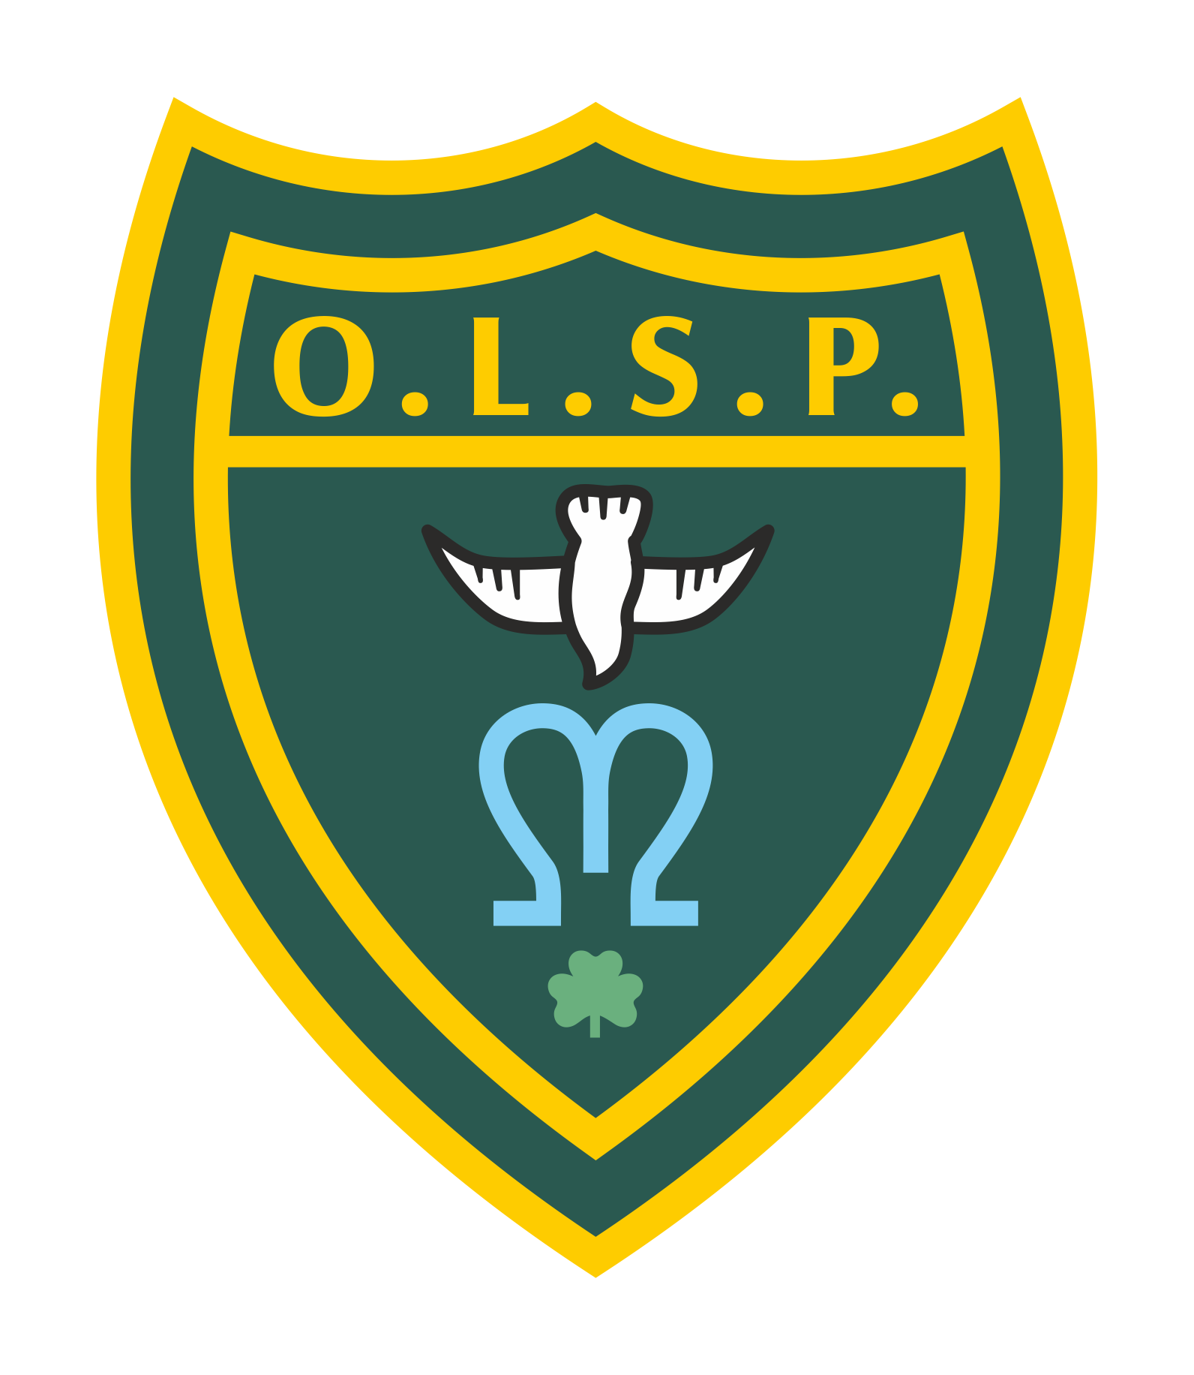
Our Lady and St Patrick’s RC Primary School

Autumn 2 2024 Curriculum Newsletter

Moons Class

 | Teacher’s Message | I hope everyone has a wonderful half-term break. We have a very busy and exciting half term ahead of us on our return, including preparation for our Nativity with the rest of KS1 and the Foundation Unit.
 | Homework | Reading: Reading will be our main focus for homework.  Phonics groups: The children who are currently part of a phonics group should bring home a bookbag book which you can share together as it will be a new book. They should also bring home a smaller phonics book which they will have read 3 times within their group so should be familiar with. The children were assessed before the end of the year and know their groups for this half-term.  Children on AR: Those children that are now reading AR (Accelerated Reader) books need to be reading at home and quizzing in school. Each morning, they will have the opportunity to quiz in school on a chrome book.  Spellings:  Phonics groups: Within the smaller phonics books that the children will bring home, it highlights (circles at the front) the sounds we are focusing on in class, the speedy green words and red words. Please look at these together.  Children on AR and not in a phonics group: These children will receive weekly spelling, punctuation and grammar homework. This will be sent home on a Friday.
 | Reading for Pleasure | This half term as a class, we will be reading a selection of wonderful stories together. These will include:  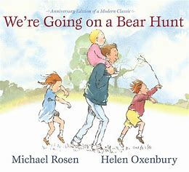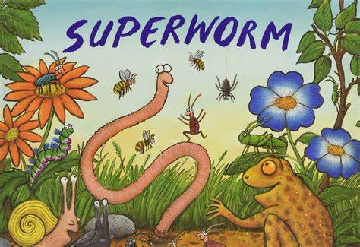
 | English | This half-term in English, we will be beginning a new unit of work based on the book, ‘Lost and Found’. This is a lovely book all about penguins, Antarctica and friendship. The children will learn the story through actions, find out information about penguins and rewrite the story using a different animal. 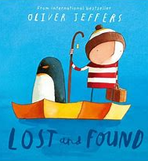  Near the end of the half term we will be focusing on ‘The Gingerbread Man’ to learn how to write instructions. We will also look at ‘The Jolly Postman’ to write our own letters to Father Christmas.
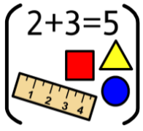 | Maths | Reception: In Maths this half term, Reception will be looking at 2D and 3D shapes and patterns.  Year 1: In Maths this half term, Year 1 will be looking at addition and subtraction within 10 and 2D and 3D shapes.
 | RE | In RE, we will be beginning a new unit called ‘Prophecy and Promise’. The focus of this branch is for children to develop an early understanding of the Christian and Catholic belief that God showed us the full depth of his love by sending Jesus his Son. In Jesus, the invisible God becomes visible, and his love is poured out as the child in the manger at Bethlehem.
 | Science | In Science this half-term, we will be continuing our learning about animals including humans. This unit of work is visited twice throughout key stage 1, but the focus is different. During this unit, we will focus on different types of animals, their offspring and how they survive. We will also be learning about the importance of exercise and a balanced diet.
 | Geography | Rivers, seas and oceans will be our focus in Geography this half term. We will be learning the difference between each one and whether humans can use land for whatever they want. Weather dependent, this will include a walk down to the back and front beaches of Teignmouth to look at the physical geography.
 | History | Not a lead subject
 | Art | Not a lead subject
 | Design Technology | In DT this term we are looking at mechanisms with a focus on sliders and levers. The children will be exploring sliders and levers before they design their own Christmas card with a slider or lever. They will then use their designs to make their own Christmas card which will move!
 | RSHE | In RSHE we will be looking at keeping safe. The children will be thinking about how to ask for help and calling 999 in an emergency.
 | PE | The children will have two PE lessons a week and will need to make sure that they have their PE kits available in school. On Thursdays, PE will be with Miss Dorrell and the children will be focusing on multi-skills. On Fridays with Premier Sports, they will working on their ball skills.
 | Computing | Not a lead subject
 | Music | In Music this term, the Musical Spotlight is, ‘The way we walk’’ and learning about simple rhythmic patterns on an instrument and having control when playing a musical instrument. They will also be learning the songs for our Nativity.
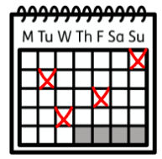 | Upcoming dates/events | 4th November INSET Day (No pupils)  12th November Odd Socks Day  17th December Rudolph Run Day 2024  20th December End of Term  6th January 2025 Beginning of Spring Term
 | Teacher contact: | Please come and see me if you have any worries or concerns. If this isn’t possible then please contact me through Class Dojo.  Please note that teachers are teaching from 8.30am - 3.15pm. If your contact is urgent please contact the school office office@olsp.uk during the school day.  There is no requirement for a teacher to reply to email or class dojo messages received in the evenings or at the weekend.

