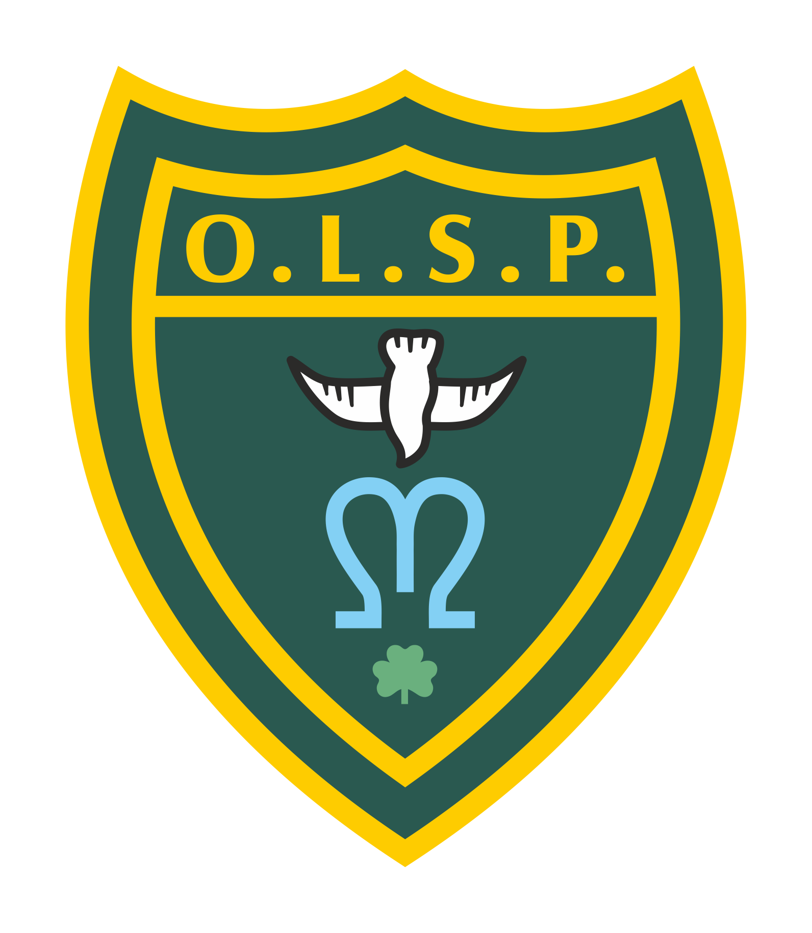
Our Lady and St Patrick’s RC Primary School

Half-termly Curriculum Newsletter

Class 6 - Supernova Class Autumn 1 2023

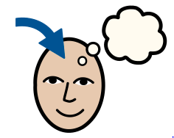 | Homework | Set on Google Classroom:  Homework is posted on Friday and the spelling test will be on the following Friday.  English:  Weekly spellings are set each Friday. Each week, the children receive a list of upto 15 words which will focus on practising spelling rules. This will be uploaded to dojo for you to access.  - Weekly spelling tests take place on Fridays.  - Please make sure regular practice takes place at home.  Maths:  - An arithmetic maths practise SATs paper will be sent home weekly on a Friday and will be due the following Friday and handed to the class teacher. Answers will be checked in a class.
 | Reading for Pleasure | This half term we will be reading Holes by Louis Sachar 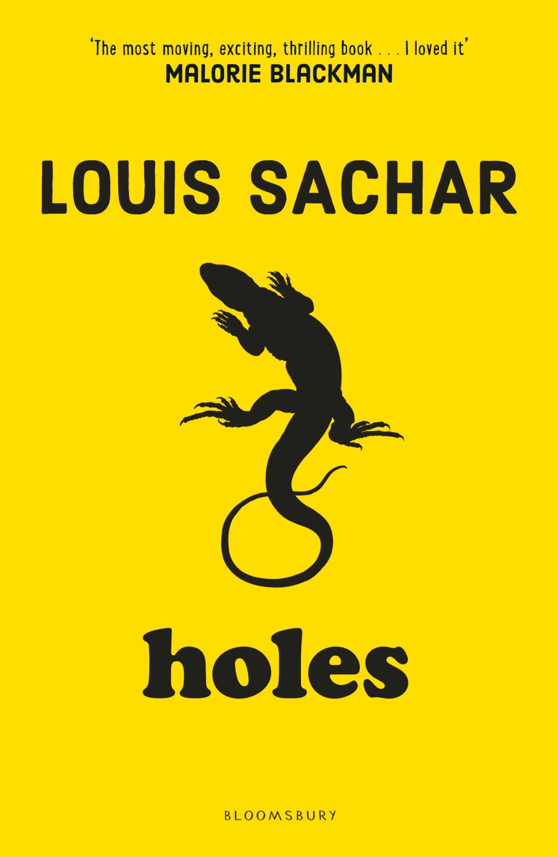
 | English | For writing, the children will be focusing on ‘How I became a Whale’. The children will listen to the story, learn how to construct sentences correctly and work towards independently writing their own tale based on ‘How I became…’  For reading, the children will be focusing on Kensuke’s Kingdom. The children will explore the 5 elements of reading Vocabulary, Inferring, Punctuation, Explaining and Summarising.  The children will have regular handwriting practise in class each week to ensure they are joining their letters correctly and fluently in year 6.  Each week, the children will have spelling lessons to support their understanding of the spelling rules. Alongside this, the children will be focusing on how to spell and use the year 5 and 6 expected spelling word list to ensure they are year 7 ready at the end of the academic year.
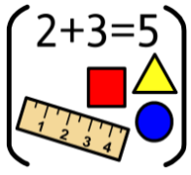 | Maths | Place Value 10,000,000.  In this unit, children extend their knowledge of numbers from within 1,000,000 up to 10,000,000, before they go on to work with the four operations in the next two units. In these units the children will be consolidating their knowledge of the effective written methods for addition, subtraction, multiplication and division.
 | RE | The unit is called ‘loving’ . The children will experience that ‘family’ in society today is varied, with many joys and sorrows. Whatever the experience, the family remains the first place for growth and development, the basic social unit.  When completed the children will move on to ‘vocation and commitment’. The children will reflect on how they are marked by many different experiences of being welcomed into new situations and groups.
 | Science | Animals including humans.  The children will be learning about the human circulation system. This unit recaps the children’s learning from year 4 about how animals survive and stay healthy and helps children to learn more about how different organ systems work. This unit teaches the importance of diet, exercise and lifestyle in the way that our bodies function. In this unit, they learn about the three main parts of the circulatory system and the job of the heart. They also learn about what blood is composed of and how it is transported around the body. Children will investigate to explore how heart rate is affected by exercise.
 | Art | The children will be learning about developing their skills using shape, form, model and join using malleable and rigid materials – wire, clay and mod rock.
 | RHE | The children will be learning about ‘Lifestyles’.  The children will learn about good physical health and how to recognise illness. The benefits of regular exercise. How exercise benefits mental health too. The children will also learn about drugs and alcohol uses / dangers of toxic substances.
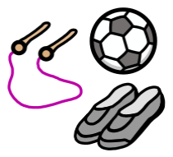 | PE | Every week, a PE lesson will be held on a Friday by a specialist PE teacher.  Each Tuesday, the children will be taught by the class teacher. The focus this half-term is Netball. The children will learn to pass, receive and shoot the ball with increasing control. The children will learn the rules of the game and consistently play honestly and fairly.  Make sure / check your child brings in their PE kit each week. Please make sure it is labelled with their name and surname.
 | Computing | Online safety is the key focus for this term. Children will know what ‘digital footprint’ means (the information that exists on the internet as a result of a person’s online activity), what steps are required to capture bullying content as evidence, they will understand that it is important to manage personal passwords effectively and know some common online scams.
 | Spanish | The children will be learning how to verbalise Spanish words based on the school environment. The children will use songs, repetition and recall to learn words linked to school such as equipment.
 | Teacher contact: | Class 6 Dojo Page.  Please note that teachers are teaching from 8.30 am - 3.15 pm. If your contact is urgent please contact the school office office@olsp.uk during the school day.  There is no requirement for a teacher to reply to emails or class dojo messages received after 6 pm or at the weekend.

