COVID-19: Outbreak Management Plan

Our Lady & St Patrick’s Catholic Primary School

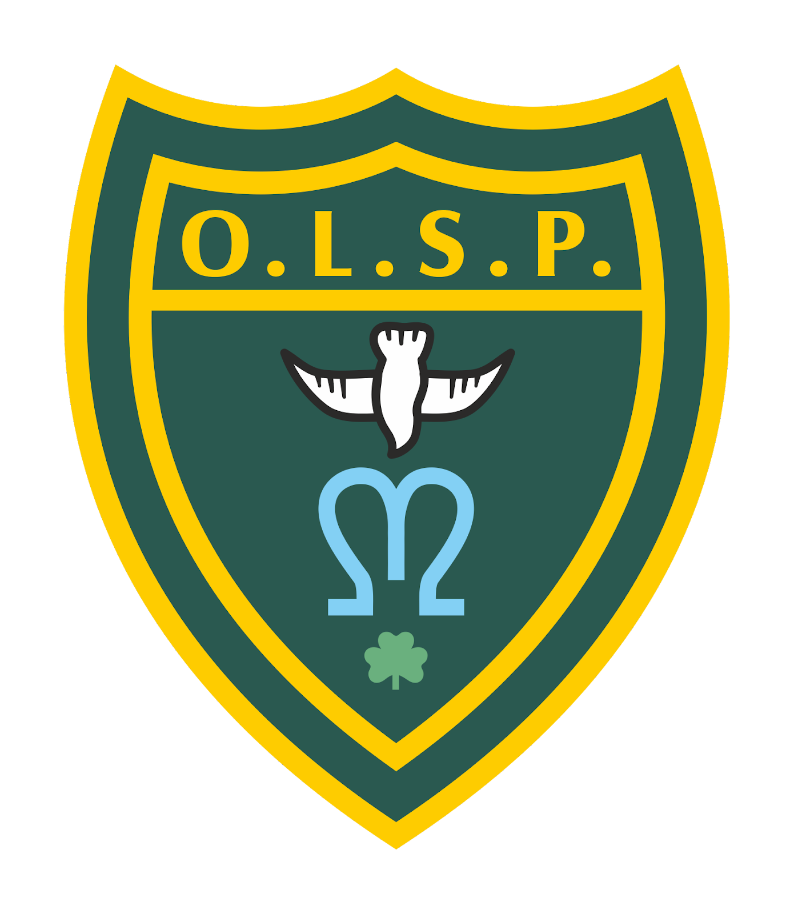

Approved by: | Cathy Lowry | Date: 12th January 2022
Last reviewed on: | 12th January 2022
Next review due by: | In line with guidance

1. Introduction
This plan is based on the contingency framework for managing local outbreaks of COVID-19 and the schools operational guidance, provided by the Department for Education (DfE).
We will only implement some, or all, of the measures in this plan in response to recommendations provided by our local authority (LA), directors of public health (DsPH), Public Health England (PHE) health protection team or the national government.
It may be necessary to implement these measures in the following circumstances, for example:
- To help manage a COVID-19 outbreak within the school. Actions will be considered when either of the following thresholds are met:
- There are 5 positive cases amongst pupils or staff who are likely to have mixed closely within a 10-day period
- 10% of pupils or staff who are likely to have mixed closely test positive within a 10-day period
- If COVID-19 infection rates in the community are extremely high, and other measures have failed to reduce transmission
- As part of a package of measures responding to a ‘variant of concern’ (VoC)
- To prevent unsustainable pressure on the NHS

2. Seeking public health advice
When one of the thresholds above is met, we will review the testing, hygiene and ventilation measures already in place.
We will also seek public health advice from a director of public health or health protection team. Cathy Lowry will be responsible for seeking this advice, and will do so by:
- Using the DfE helpline (0800 046 8687)
- The local Public Health Team using the smart survey
- The SW Public Health England Health Protection Team (0300 303 8162)

3. Shielding
We will adhere to national guidance on the reintroduction of shielding, which would apply to those on the shielded patient list (SPL).
We will speak to individuals required to shield about additional protective measures in school or arrangements for home working or learning.

4. Other measures
Parents, carers, pupils and staff will be informed promptly about the introduction of control measures. This will be done via parent mail once a decision has been made.
If recommended, we will limit:
- Residential educational visits
- Open days
- Transition or taster days
- Parents coming into school
- Live performances

If recommended, we will (re)introduce:

- Bubbles, to reduce mixing between groups
- Face coverings in communal areas and classrooms for staff and visitors (unless exempt)
- Staggered starts and ends to the school day
- Staggered lunchtimes and break times
- Restrictions on assemblies/liturgies
- Restrictions on staff meetings
- Restrictions on use of some communal areas such as staff rooms and reprographic rooms.
- Restrictions on communal lettings
- Other measures as detailed in COVID-19 Risk Assessment Dated:5.1.2022 and found on the school’s website

5. Attendance restrictions
Attendance restrictions will only be recommended as a last resort. If recommended, we will implement the measures in this section.
5.1 Eligibility to remain in school
If restrictions are recommended, we will stay open for:
- Vulnerable pupils
- Children of critical workers
5.2 Education and support for pupils at home
All other pupils will be required to stay at home and will receive remote education.
We will aim to deliver remote education that meets the same quality and quantity of education that pupils would receive in school, as outlined in our remote education policy, found on our website.
The school will continue to provide meals or lunch parcels for pupils eligible for benefits-related free school meals while they are not attending school because of COVID-19 isolation guidelines.
5.3 Wraparound care
We will limit access to before and after-school activities and wraparound care during term time and school holidays to those that need it most.
We will communicate who will be eligible to attend once the restrictions are confirmed.
5.4 Safeguarding
We will review our child protection policy to make sure it reflects the local restrictions and remains effective.
We will aim to have a trained DSL or deputy DSL on site wherever possible.
If our DSL (or deputy) can’t be on site, they can be contacted remotely by the school office.
If our DSL (or deputy) is unavailable, we will share a DSL with St Nicholas Catholic Primary School in Exeter/ Their DSL can be contacted by telephoning (01392) 445403
On occasions where there is no DSL or deputy on site, a senior leader will take responsibility for co-ordinating safeguarding on site.

When vulnerable pupils are absent, we will:
- Speak to parents/carers and, where applicable, social workers and the local authority, to work out the reason for absence
- Encourage attendance
- Make sure vulnerable pupils can access appropriate education and support while at home
- Maintain contact, and check regularly that the pupil is able to access remote education provision

Contact Details
Organisation/Individual | Telephone Number | Email Address
DfE COVID-19 Helpline  Mon-Fri: 8.00am -6.00pm  Sat-Sun: 10.00am- 6.00pm | 0800 046 8687  If necessary, the DfE helpline will escalate to the PHE SW Health Protection Team for further risk assessment
Director of Public Health (DPH)
Local Health Protection Team (HPT)
NHS Test and Trace  (supply, order, delivery of test kits) | 119
Education Standards Manager (ESM) |  | Charlotte.Targett@plymouthcast.org.uk

