Our Lady and St Patrick’s RC Primary School

Autumn 1 Curriculum Newsletter

Class 5 - Neptune Autumn 1 2023

 | Teacher’s Message | Hello and welcome to all of the pupils and families new to Year 5! We hope you have had a wonderful Summer and are ready to return to a new year of learning.  We are Mrs Mullane (Mon-Wed) and Mrs Compton-Stewart (Thurs-Fri). Please do come and speak to us if you have any questions or just want to put a name to a face.  In this newsletter, you will find information about the various things we will be learning about and exploring in the first half of the Autumn term.
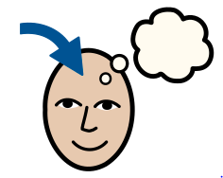 | Homework | Homework is posted on a Monday and the spelling test will be on a Friday.  English:  Weekly spellings are set each Monday. Each week, the children receive a list of 10 words which will focus on practising new spelling rules. The spellings will be uploaded on Class Dojo and a copy will be sent home for the children to practise.  - Weekly spelling tests take place on Fridays.  - Please make sure regular practice takes place.  Maths:  Later on in the term, pupils will be learning their times-tables whereby they will have a particular set of tables to focus on each week.  I will post more information about this in due course later on in the term.
 | Reading for Pleasure | For this half term, the children will be reading Cogheart by Peter Bunzl.  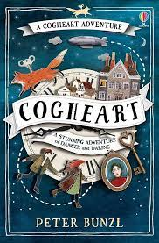
 | English | This half term, the children will be exploring and unpicking the text ‘Kensuke’s Kingdom’ by Michael Morpurgo. This is an exciting and engaging adventure story packed with descriptive language. The children will be using this example to use ‘show not tell’ in their own writing, where they will be expected to use characters’ actions, the weather and other tools to demonstrate how a character is feeling without spelling it out.  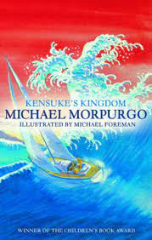  After we have finished this unit, we will move on to ‘The Tear Thief’ by Carol Ann Duffy.  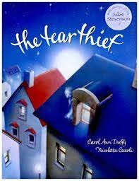
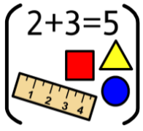 | Maths | In maths, the children will begin with a place value unit where they explore the value of each digit within a number. After this, we will be moving on to addition and subtraction.
 | RE | Throughout RE, all children follow the ‘Come and See’ programme. To begin with, children will explore and reflect on themselves and their relationship with God in our topic ‘Ourselves’.
 | Science | In science, the children will be learning about the changes humans go through as they progress through the key different life stages from birth to being elderly. The will develop scientific skills such as measuring and recording accurately and thinking critically.
 | History | For history this term, the children will be learning all about the Ancient Mayan civilisation. They will learn about how it was founded, how long it spanned, how the civilians lived, and we will compare these findings to how we live today in Britain.
 | Geography | Not a lead subject this term.
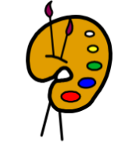 | Art | In art, the children will be exploring colour. They will learn about primary and secondary colours practically and apply their knowledge to their own painting.
 | Design Technology | Not a lead subject for this term.
 | RSHE | Within RSHE and PSHE, the children will be following the ‘Life to the Full’ programme alongside the PSHE association materials.  This half term, the children will hear stories in our unit ‘Calming the Storm’ before we move on to ‘Is God calling you?’.
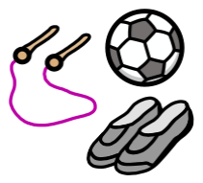 | PE | In PE, the children will be learning the skills and rules of tag rugby and netball.  PE will be taken on a Tuesday and Thursday.  Please ensure your child brings in their PE kit on these days and it is clearly labelled with their first name and surname.
 | Music | For music, the children will be taught by Mr Hopkins on a Thursday morning. The children will be learning how to play different musical instruments together collectively.
 | MFL (Y3+) | In Spanish, Mrs Emmerton will be teaching the children on a Tuesday afternoon. The children will be learning to answer questions and talk about themselves.
 | Computing | For computing, the children will be learning about online safety and different ways with how we can keep safe online when using the internet.
 | Teacher contact: | Please come and see me if you have any worries or concerns. If this isn’t possible then please contact me through Class Dojo.  Please note that teachers are teaching from 8.30am - 3.15pm. If your contact is urgent please contact the school office office@olsp.uk during the school day.  There is no requirement for a teacher to reply to email or class dojo messages received after 6pm or at the weekend.

