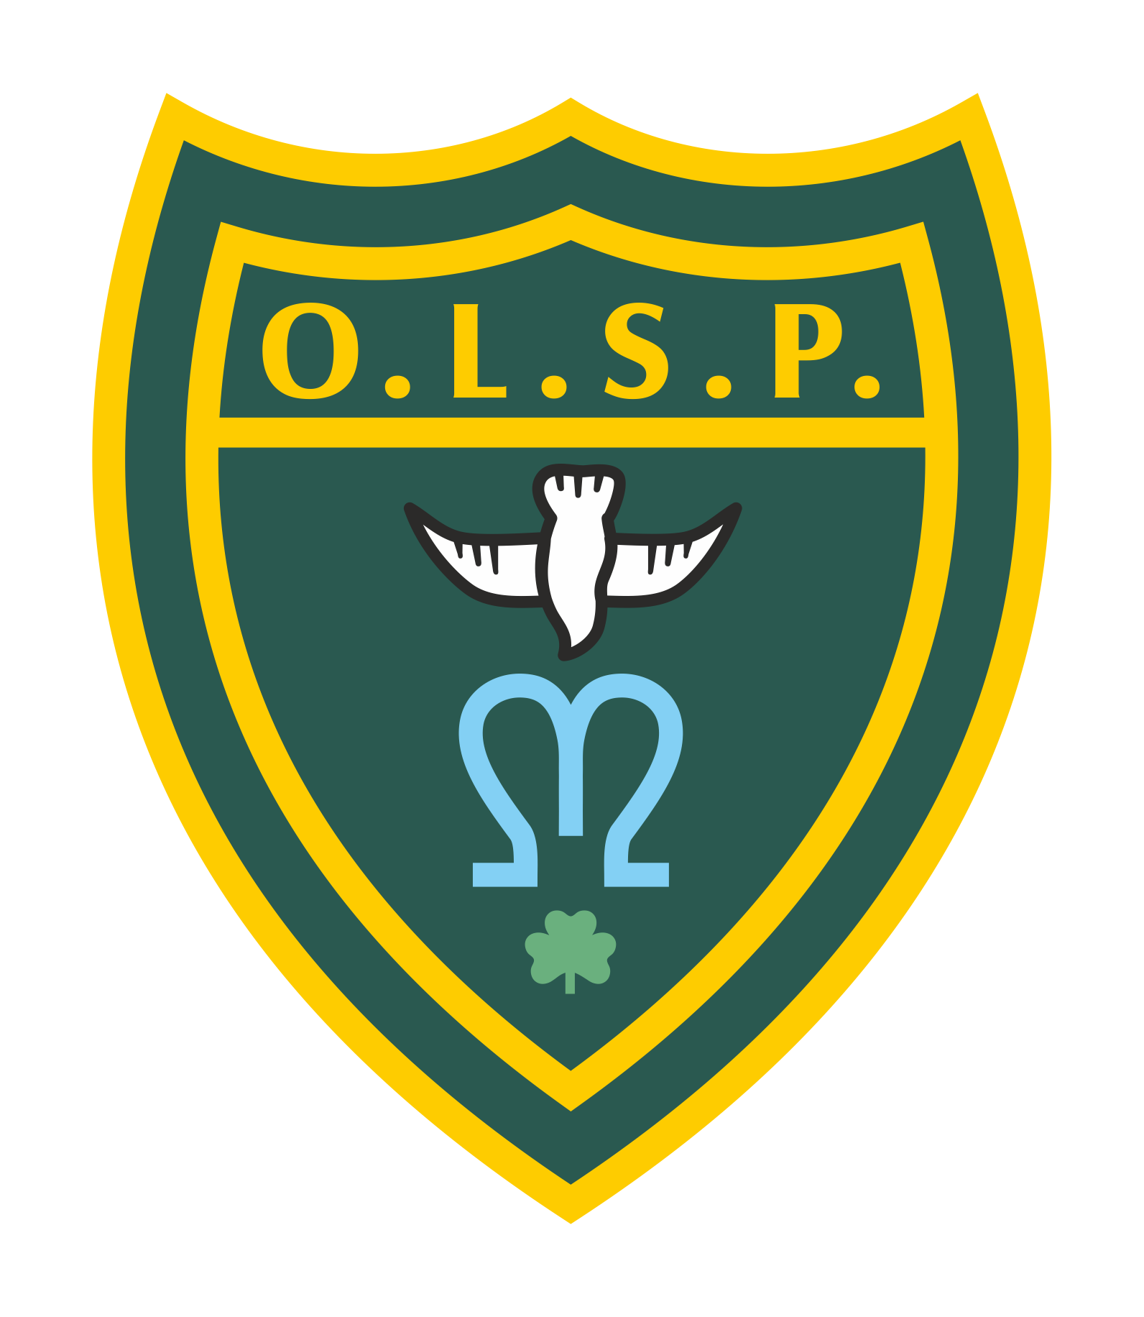
Our Lady and St Patrick’s RC Primary School

Half Termly Curriculum Newsletter

Class: EYFS Spring 1

 | Teacher’s Message | We hope you all had a wonderful break. We have another busy half term planned for EYFS. The children have particularly enjoyed attending the library and choosing new books to share with you; this will continue.
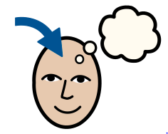 | Homework | We have very much started our phonics journey. Please encourage the children to review their sounds. You can ask them “What is your sound of the day today?”  “How do you write that sound?”  Children will be coming home with green words to practice their word reading please encourage your children to use ‘Fred talk’ and ‘Read the Word’
 | Reading for Pleasure | Please continue to share lots of stories with your children. Consider a variety of texts like some non fiction fact books alongside some traditional tales. The children have enjoyed showing us their reading records too and talking about their favourite books.
 | Reading | We will be reading regularly in class this half term focusing on a variety of stories from different authors, storytelling and looking closer at the illustrations.
 | Literacy | We will be linking our learning to our history topic of superheroes. Our first text will be Supertato making our own comic strips. Including wow words and illustrations we will also be looking at comics for inspiration.
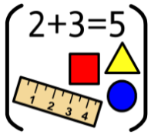 | Maths | In Maths we will be looking at numbers to 10, comparing numbers within 10 and addition. In the provision we will be exploring measurements including length, weight and height.
 | RE | Our focus in RE this half term is Celebrating. We will be talking about how we celebrate? How does it feel to be surprised? How did you celebrate over the holiday?
 | Science | In Science we will be looking at seasonal changes and noticing what we can spot in the environment. Welly walks will continue to support this followed by living things and their habits. We will be discussing where animals live and what they need in their habitats.
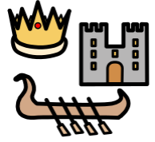 | History | We will be looking at superheroes in history. We will learn about amazing doctors and nurses throughout history. We will also look at inventors, how their inventions started, what they look like now and looking at similarities and differences.
 | Geography | Not a lead subject this half term.
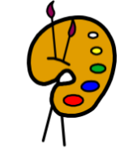 | Art | In Art we will continue to explore different mediums to create our masterpieces. We will be having an emphasis on drawing and improving our skills.
 | Design Technology | Not a lead subject this half term.
 | RSHE | In these sessions children will be discussing special people and relationships with friends. We will also be looking at how to keep safe in various situations.
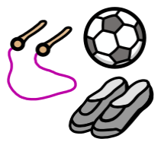 | PE | In PE we will be doing gymnastics, creating a routine within a group.
 | Music | Music lessons will be focussing on songs that tell a story and will be helping us hone our listening skills.
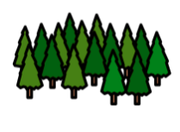 | Welly Walks / Forest School | Continuing every Thursday- children are to come in in their own clothes with school uniforms in bags.
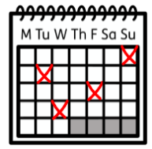 | Upcoming dates/events | 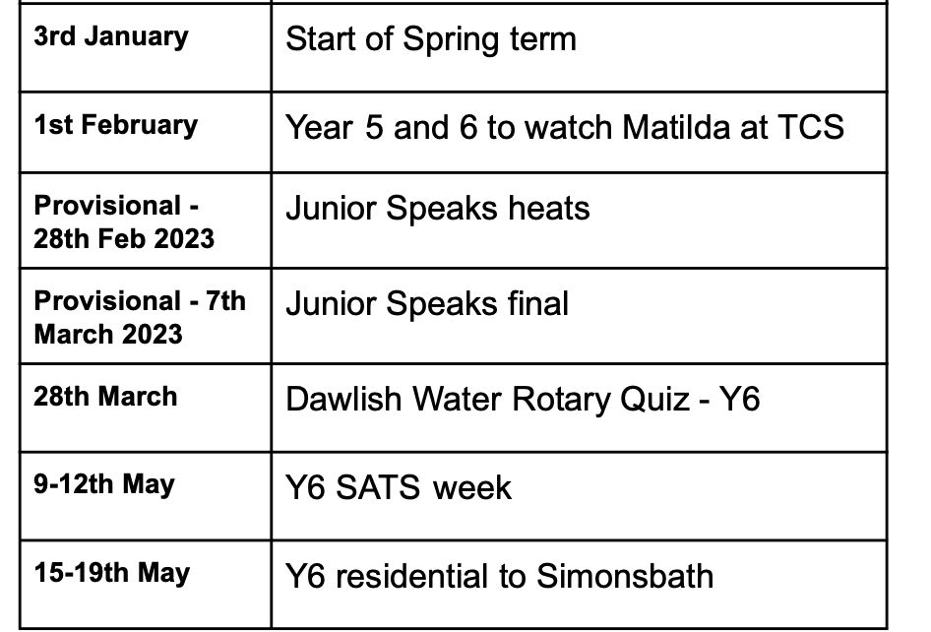
 | Teacher contact: | aokane@olsp.uk  Please note that teachers are teaching from 8.30am - 3.15pm. If your contact is urgent please contact the school office office@olsp.uk during the school day.  There is no requirement for a teacher to reply to emails received after 6pm or at the weekend.

