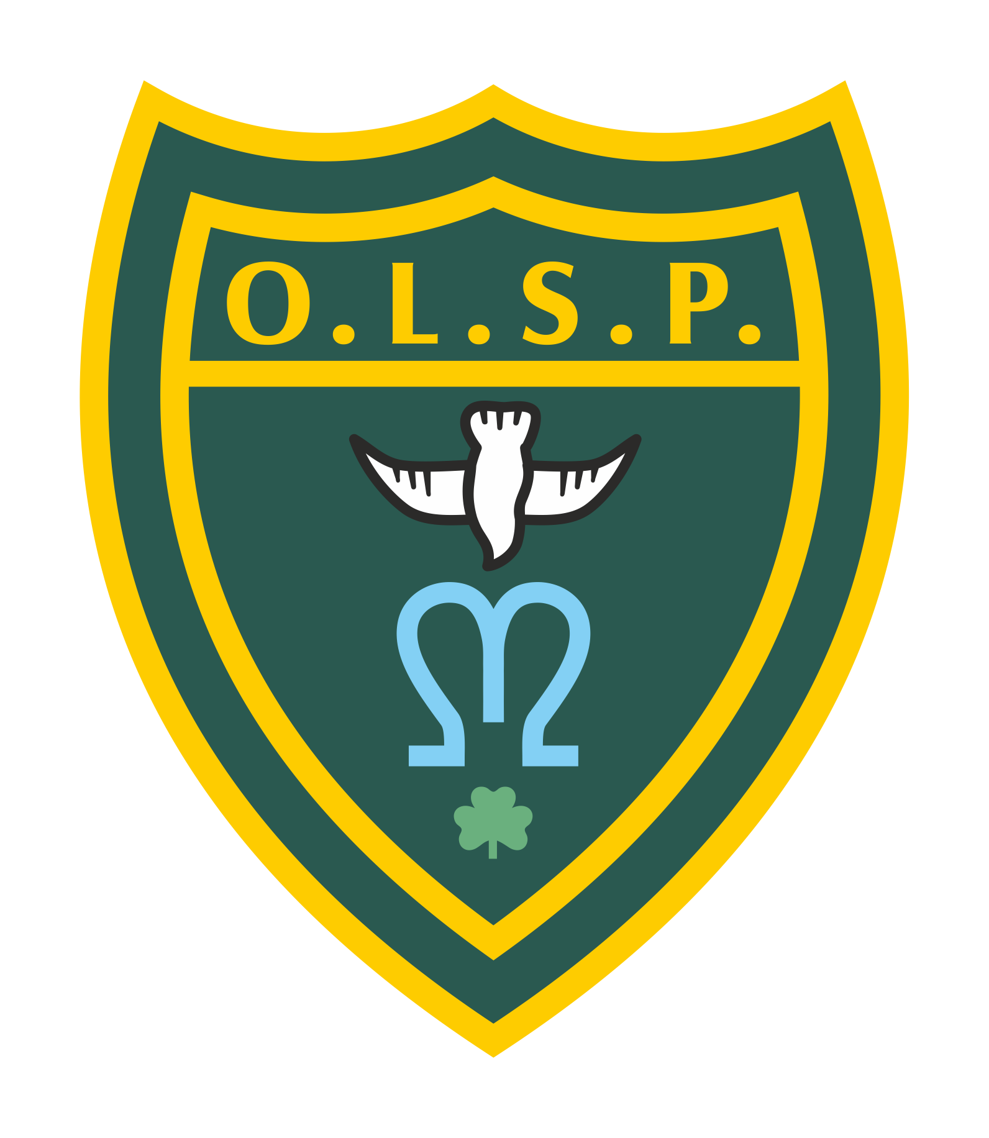
Our Lady and St Patrick’s RC Primary School

Half Termly Curriculum Newsletter

Class: EYFS Autumn 2

 | Teacher’s Message | We hope you all had a wonderful half term. We have a busy half term planned for EYFS, the children have particularly enjoyed ‘welly walking’ which will continue and we will be introducing weekly cooking lessons this half term. Building works should be getting firmly underway in our outside area. We are very excited to see the final product.
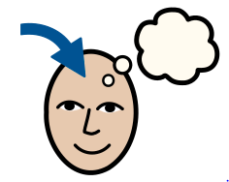 | Homework | We have very much started our phonics journey. Please encourage the children to review their sounds. You can ask them “What is your sound of the day today?”  “How do you write that sound?”  We will also be focusing on name writing and number formation. You will also be receiving formation sheets coming home with your children to really focus on what the sounds look like.
 | Reading for Pleasure | The children in class EYFS have enjoyed their new dinosaur themed book corner which includes new dinosaur story books and dino reading buddies. Dave the dinosaur is a class favourite.  Children will be going to the library every Wednesday where they will have the opportunity to select a book to share with you. These will need to be returned by the following Wednesday to be exchanged for a new book.
 | Reading | We will be reading regularly in class this half term focusing on stories and storytelling.
 | Literacy | We will be focusing on the story of ‘The Gingerbread Man’ this half term. We will be exploring the story characters and sequence of what happens. We will be making our own gingerbread people and retelling the story in our own words.
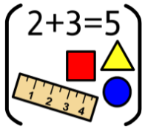 | Maths | In Maths we will be looking at number bonds to 5, space and numbers to ten.
 | RE | Our focus in RE this half term is welcome. We will be talking about how we welcome people? How does it feel to be welcomed? How would a family welcome a new baby? And how are people welcomed into God's family? Linking in discussions about Baptism.
 | Science | In Science we will be exploring everyday materials. Looking at how they are used? What is their purpose? And What qualities do they have?
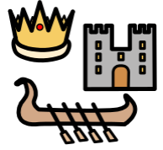 | History | Not a lead subject this half term.
 | Geography | In Geography we will be investigating different celebrations around the world. We will be looking at Yi Peng in Thailand, Diwali in India, Hannuka and how Christmas is celebrated around the world.
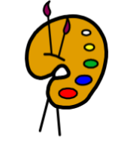 | Art | Not a lead subject this half term.
 | Design Technology | During DT sessions we will be looking a bit closer at construction and looking at structure of things considering the inside and outside of them.
 | RSHE | We will be looking at firework safety and discussing people who keep us safe at school and home.
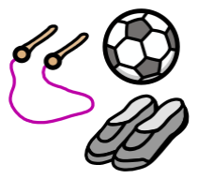 | PE | We are establishing a routine of changing and settling and then we will be practising movement and shape in our PE lessons.
 | Music | In music we will be learning lots of new songs for our nativity performance in December.
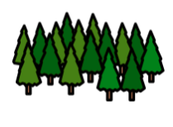 | Welly Walks / Forest School | Continuing every Thursday- children are to come in in their own clothes with school uniforms in bags.
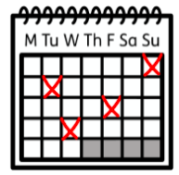 | Upcoming dates/events | 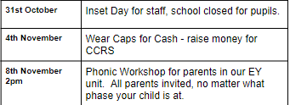  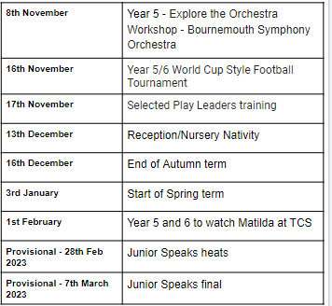
 | Teacher contact: | aokane@olsp.uk  Please note that teachers are teaching from 8.30am - 3.15pm. If your contact is urgent please contact the school office office@olsp.uk during the school day.  There is no requirement for a teacher to reply to emails received after 6pm or at the weekend.

